|  |
| --- |
| Creating Web Application |
| COS10011  Semester 1, 2021 |
|  |
|  |
|  |

|  |  |
| --- | --- |
| Member Name | Member ID |
| Amirul Iman bin Amran | 101234444 |

|  |
| --- |
|  |

Table of Contents

Assignment 1 3

1.1 Introduction 3

1.1.1 Background 3

1.1.2 Objectives 3

1.1.3 Scope of the website 3

1.1.4 Intended audience 3

1.2 Webpage Design and Structure 4

1.2.1 Website Layout Mock-ups 4

1.2.2 Website Structure 4

1.3 End Product 5

1.3.1 Actual User Interface 5

1.3.1.1 Index 5

1.3.1.2 Food Delivery 6

1.3.1.3 Recipes 7

1.3.1.4 Booking 9

1.3.1.5 Jobs 10

1.3.1.6 About Mangkuk 11

1.3.1.7 About me 12

1.3.1.8 Enquiry 12

1.3.1.9 Enhancement 13

1.3.1.10 Disclaimer 13

1.3.1.11 Mobile view 14

1.3.1.12 Explanation 15

1.3.2 Enhancements 15

1.3.2.1 Flip Cards 15

1.3.2.2 Slideshow with buttons 15

1.3.2.3 Google Map 15

Assignment 2 16

2.1 Description 16

2.1.1 Validation 16

2.1.2 Data Transfer – between pages 18

2.1.3 Data Transfer – within pages 19

2.1.4 Array 23

2.2 End Product 25

2.2.1 Enhancements 25

2.2.1.1 Slideshow 25

2.2.1.2 Real-time clock 25

2.2.1.3 Scroll back to top button 26

Assignment 3 27

Description 27

Basic requirements 27

head.php 27

navigation.php 27

header.php 28

footer.php 28

enquiry.php 29

enquiry_process.php 30

view_enquiries.php 31

MySQL database structure/schema 32

End Product 33

User Management Module 33

Confirmation 35

# Assignment 1

## Introduction

### 1.1.1 Background

* Most existing restaurants do not fully take advantages of internet platform such as a website.
* Restaurants have to adapt to current technology to grow.
* Restaurants will gain many benefits from using a website that can enhance their performance.
* A website opens doors for restaurants to do multi-tasking and reach people from different places and time at the same time.

### 1.1.2 Objectives

* Boosting restaurant profitability by expanding its products with utilising food delivery.
* Encouraging customers to be part of the restaurant ecosystem allows them to view and learn the food recipes.
* Diversifying its product by just selling foods and booking restaurant venue, catering service, and renting restaurant kitchen appliances.
* Employing people in a more accessible and effective way by releasing job application on the website.

### 1.1.3 Scope of the website

* Food Delivery
* Recipe tutorials for people to learn
* Booking restaurant venue, catering and kitchen appliances
* Job hunting

### 1.1.4 Intended audience

* Restaurant owners
* All age ranges because food is for everyone
* Early cooking beginners
* Event planners
* People who are seeking for jobs

## Webpage Design and Structure

### 1.2.1 Website Layout Mock-ups

**Body**

**Footer**

**Navigation**

* Index
* Food delivery
* Recipes
* Booking
* Job
* About Mangkuk
* About Author
* Enquiry
* Disclaimer

### 1.2.2 Website Structure

## 1.3 End Product

### 1.3.1 Actual User Interface

#### 1.3.1.1 Index

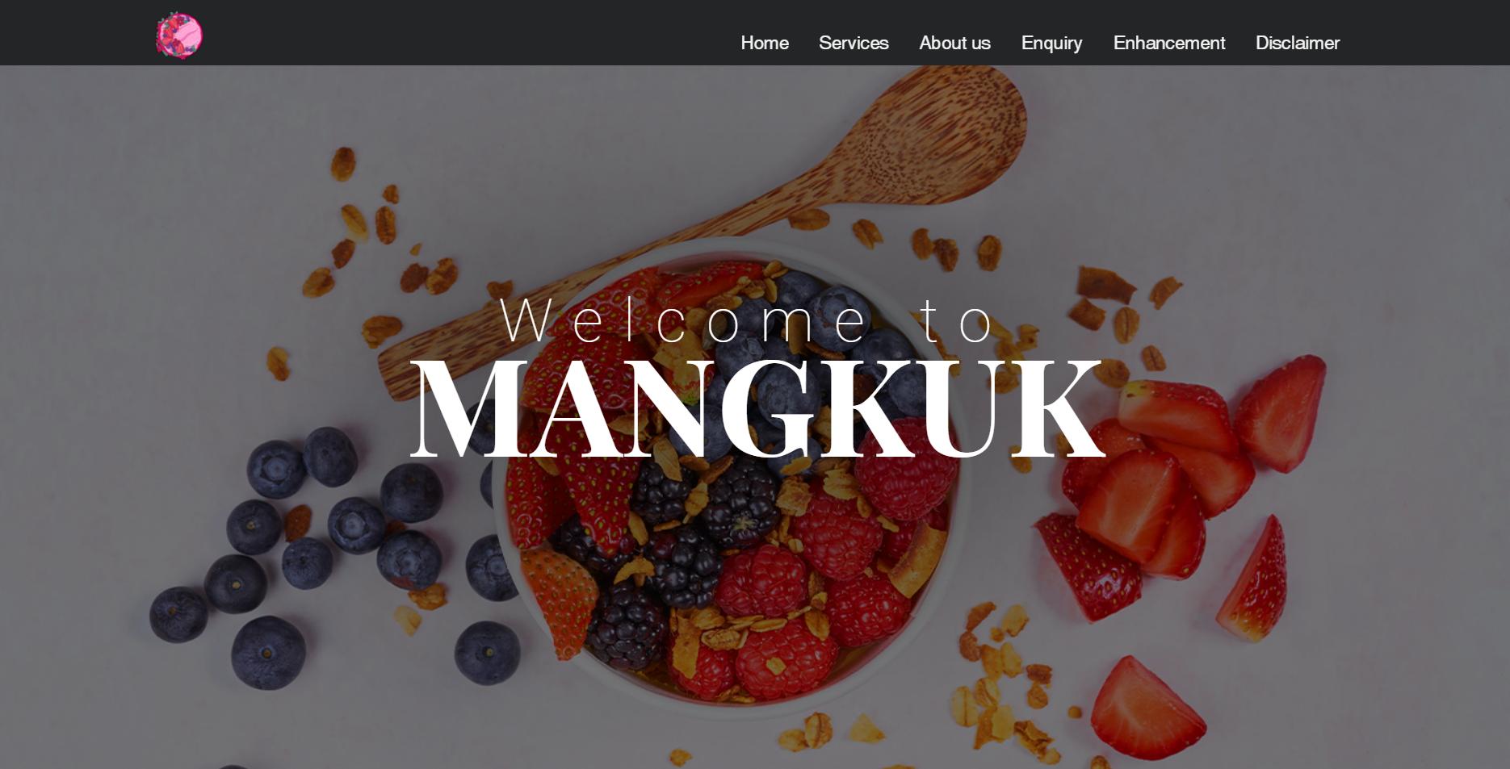

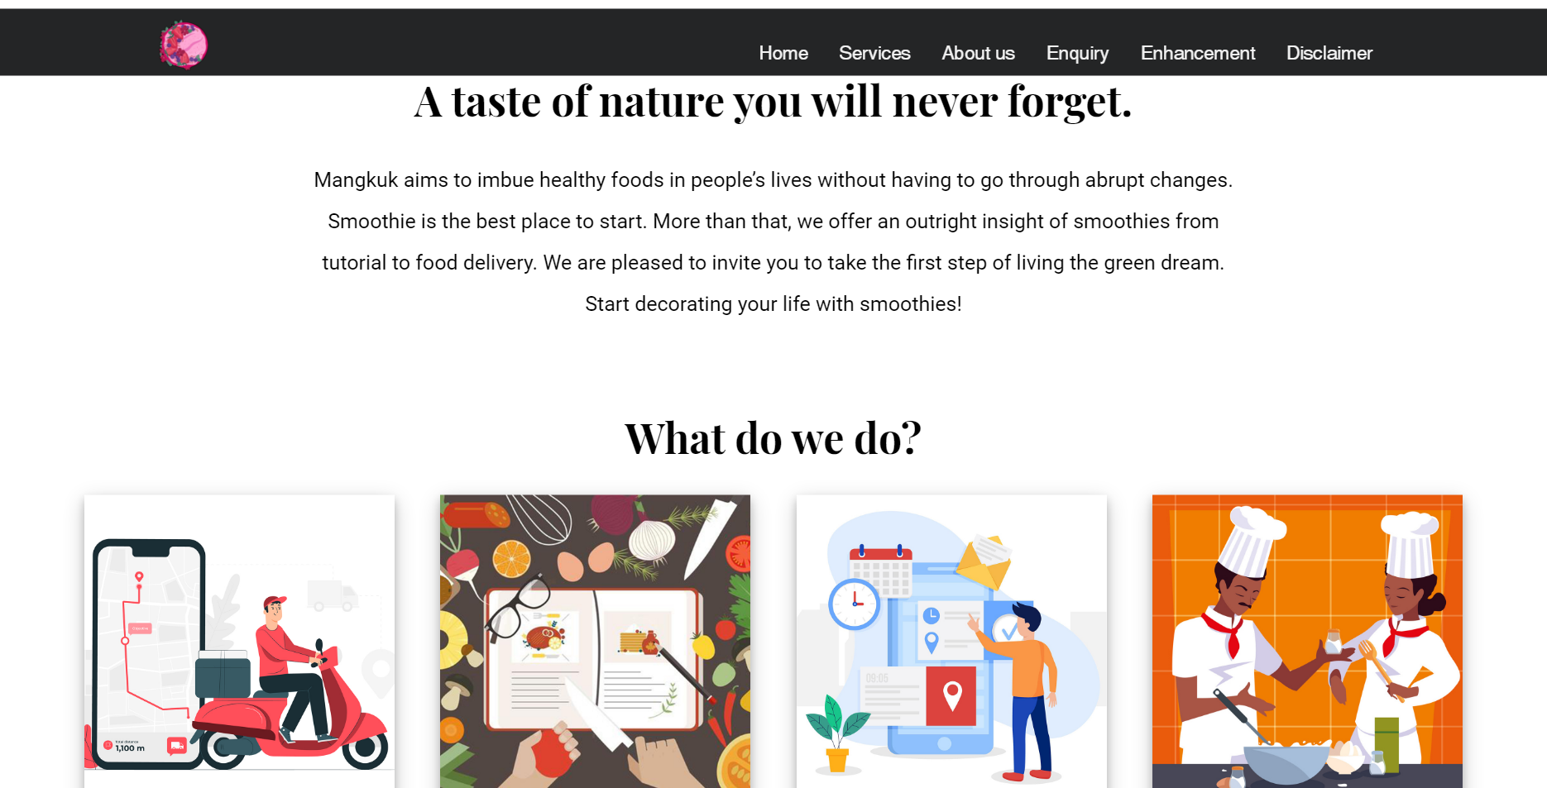

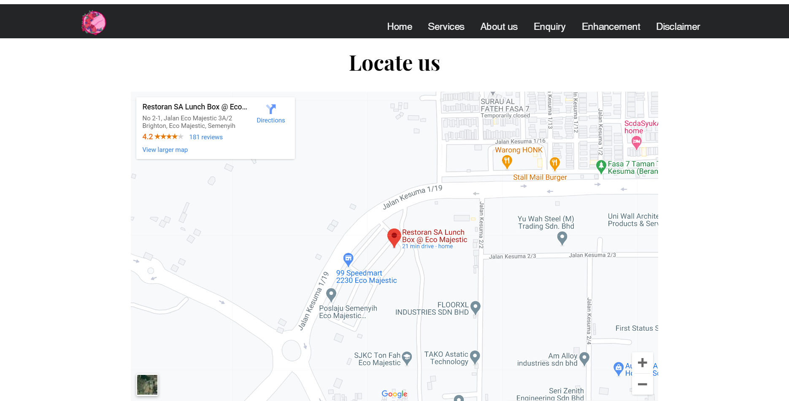

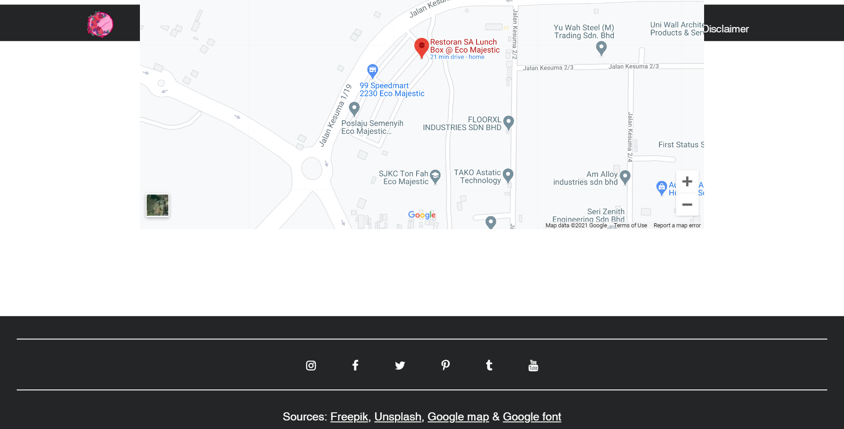

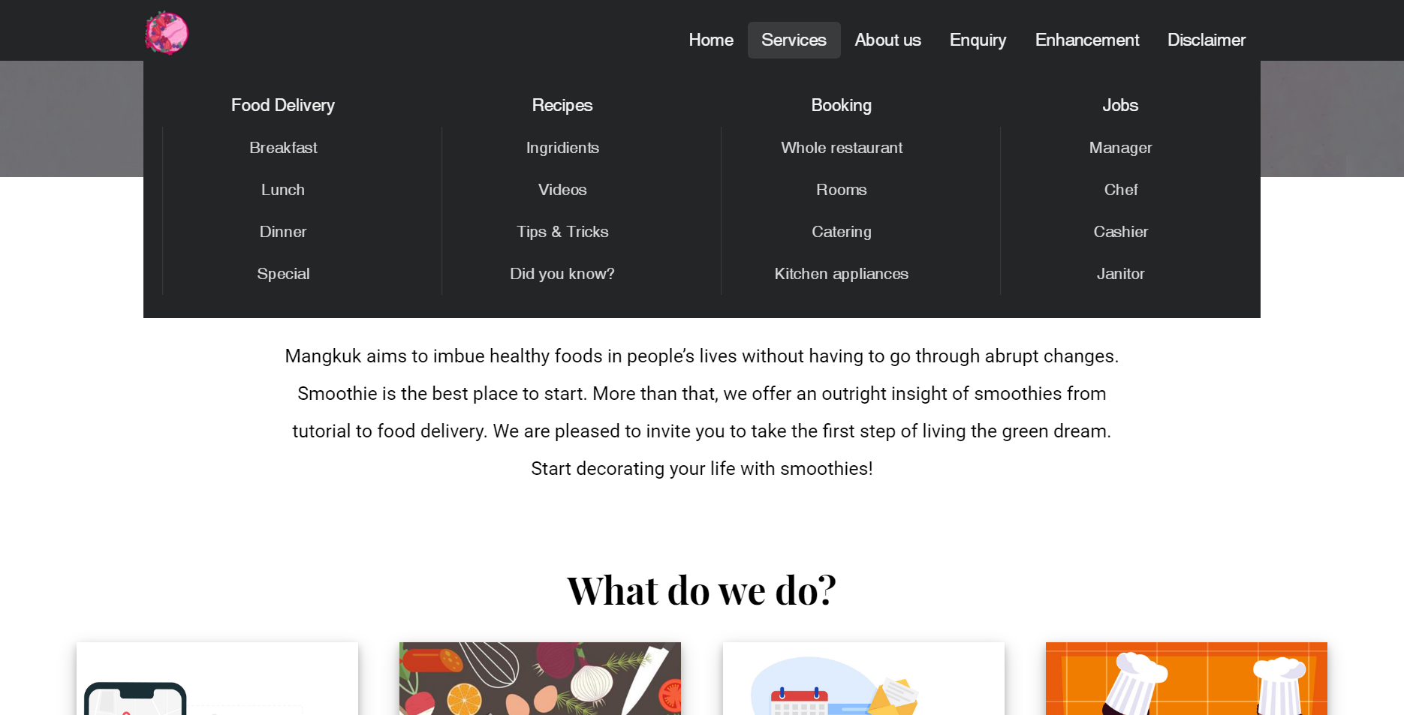

#### 1.3.1.2 Food Delivery

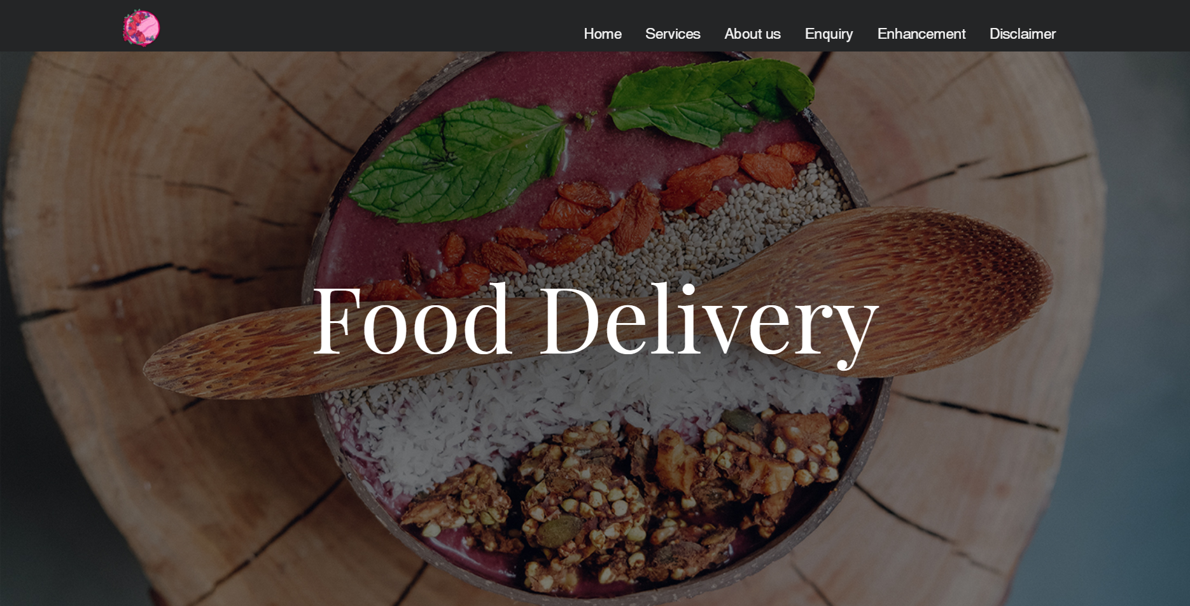

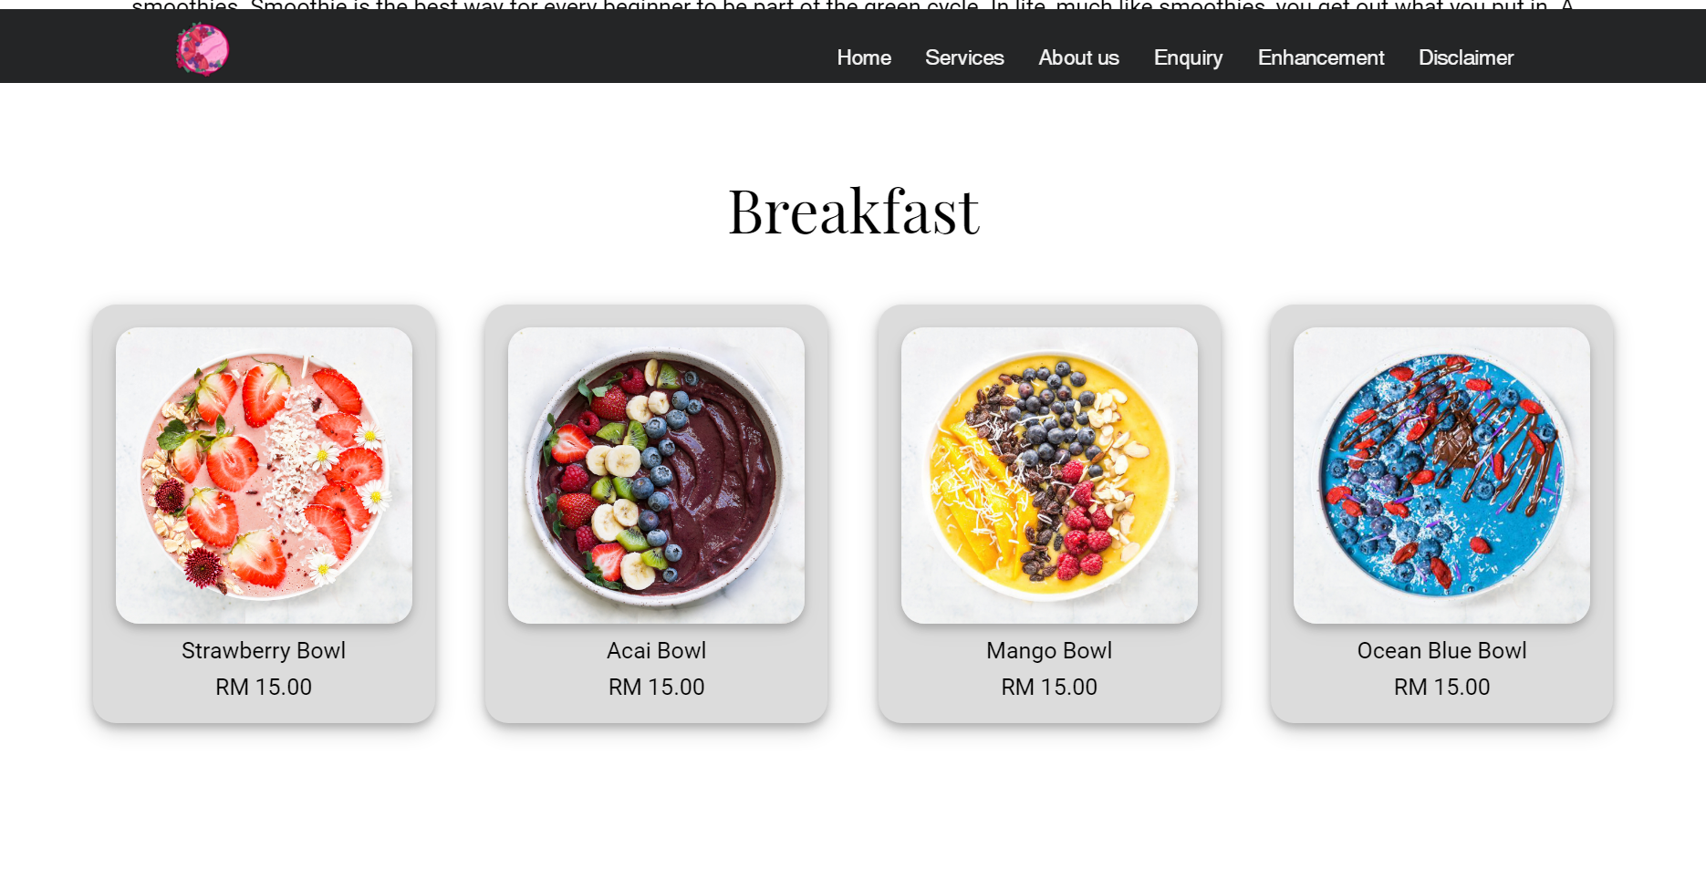

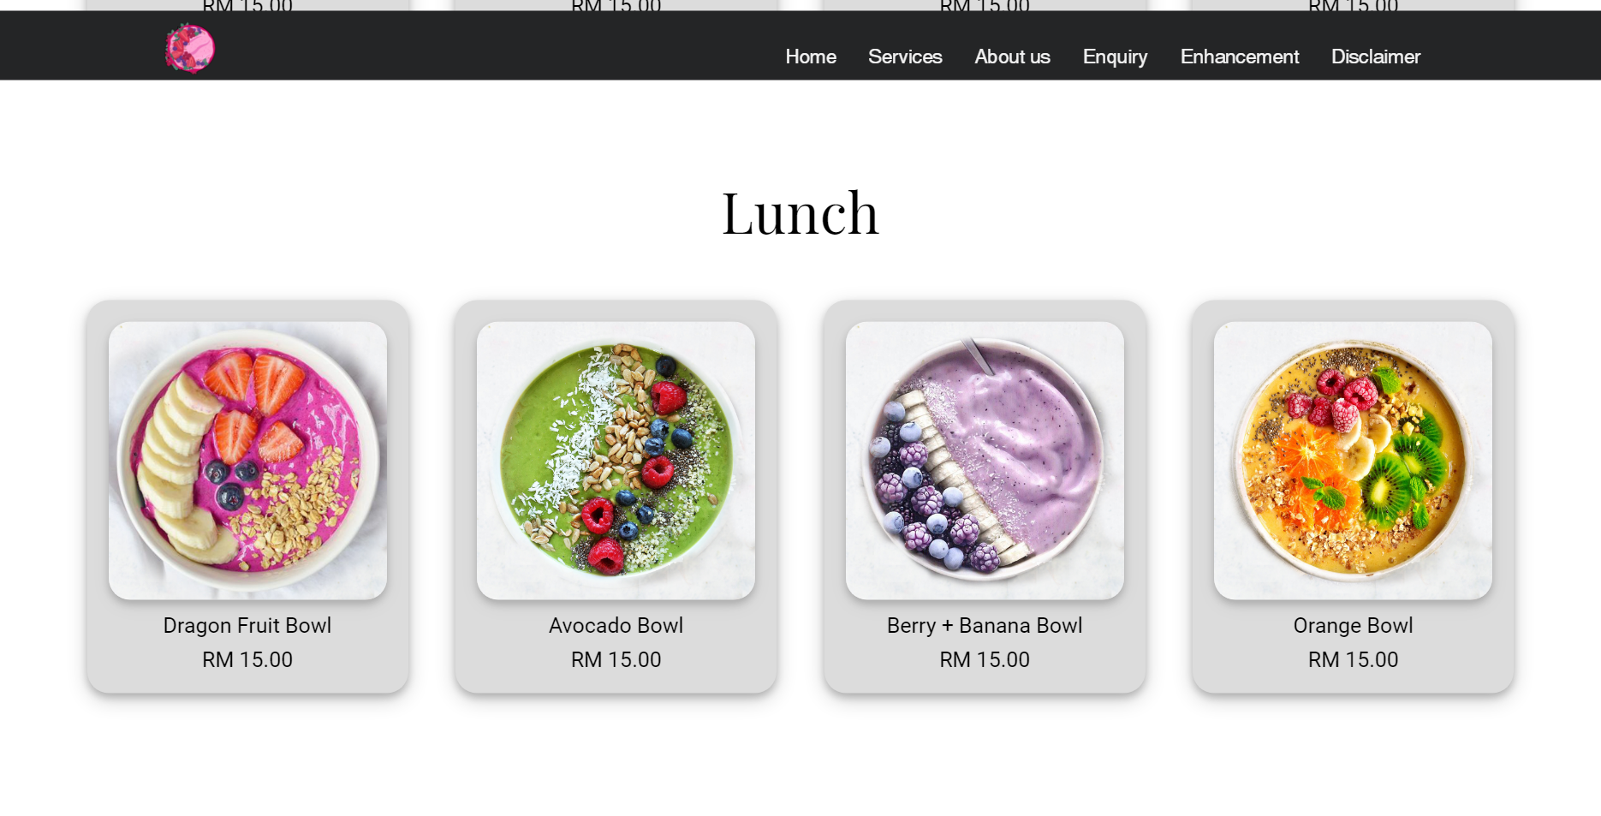

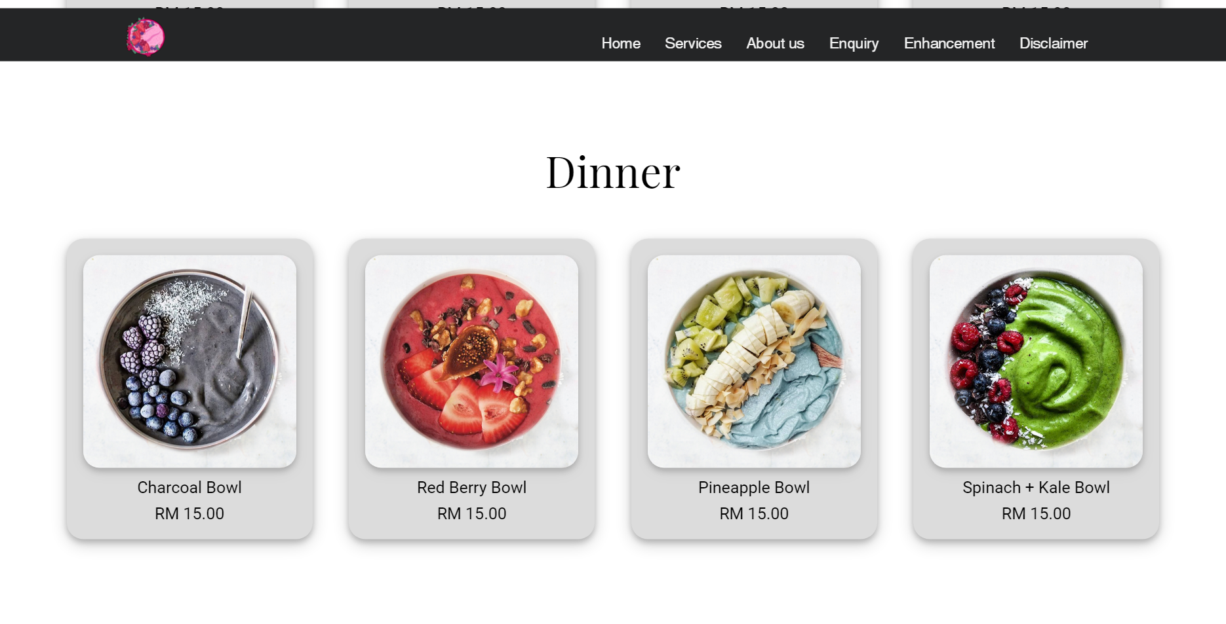

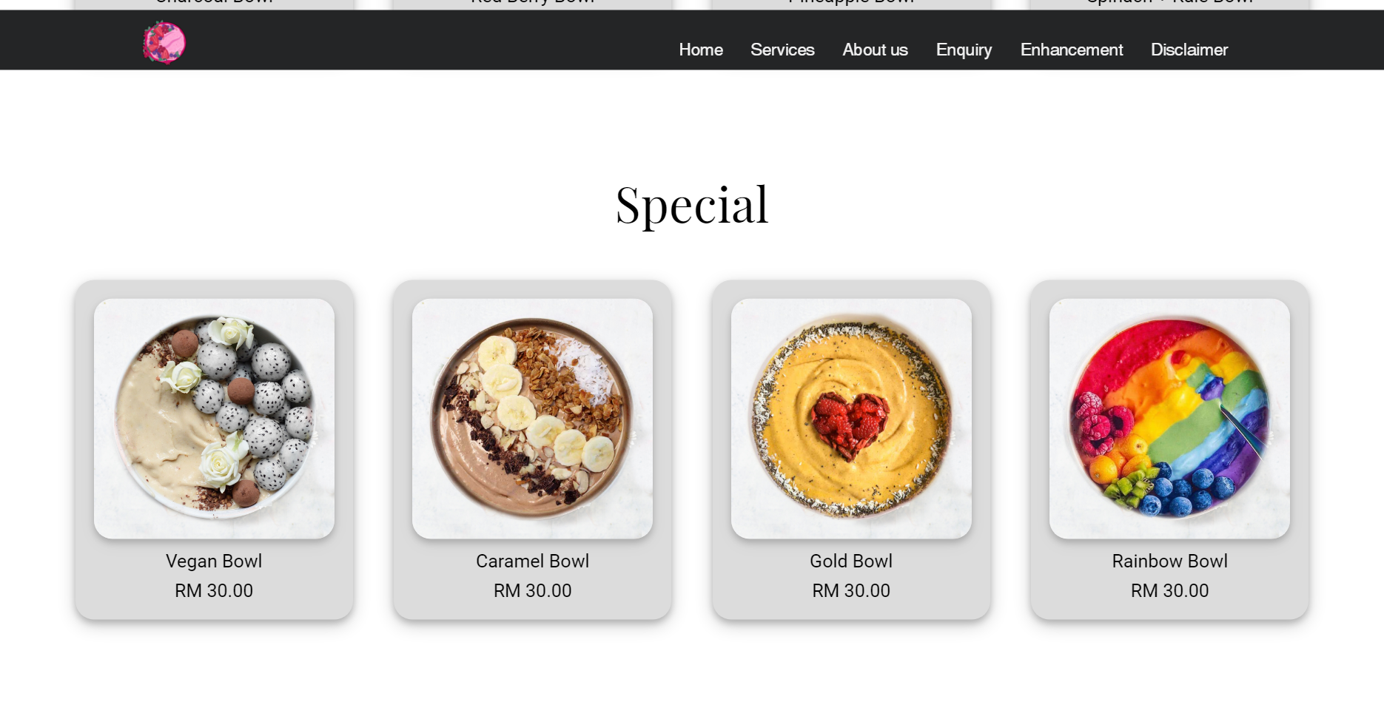

#### 1.3.1.3 Recipes

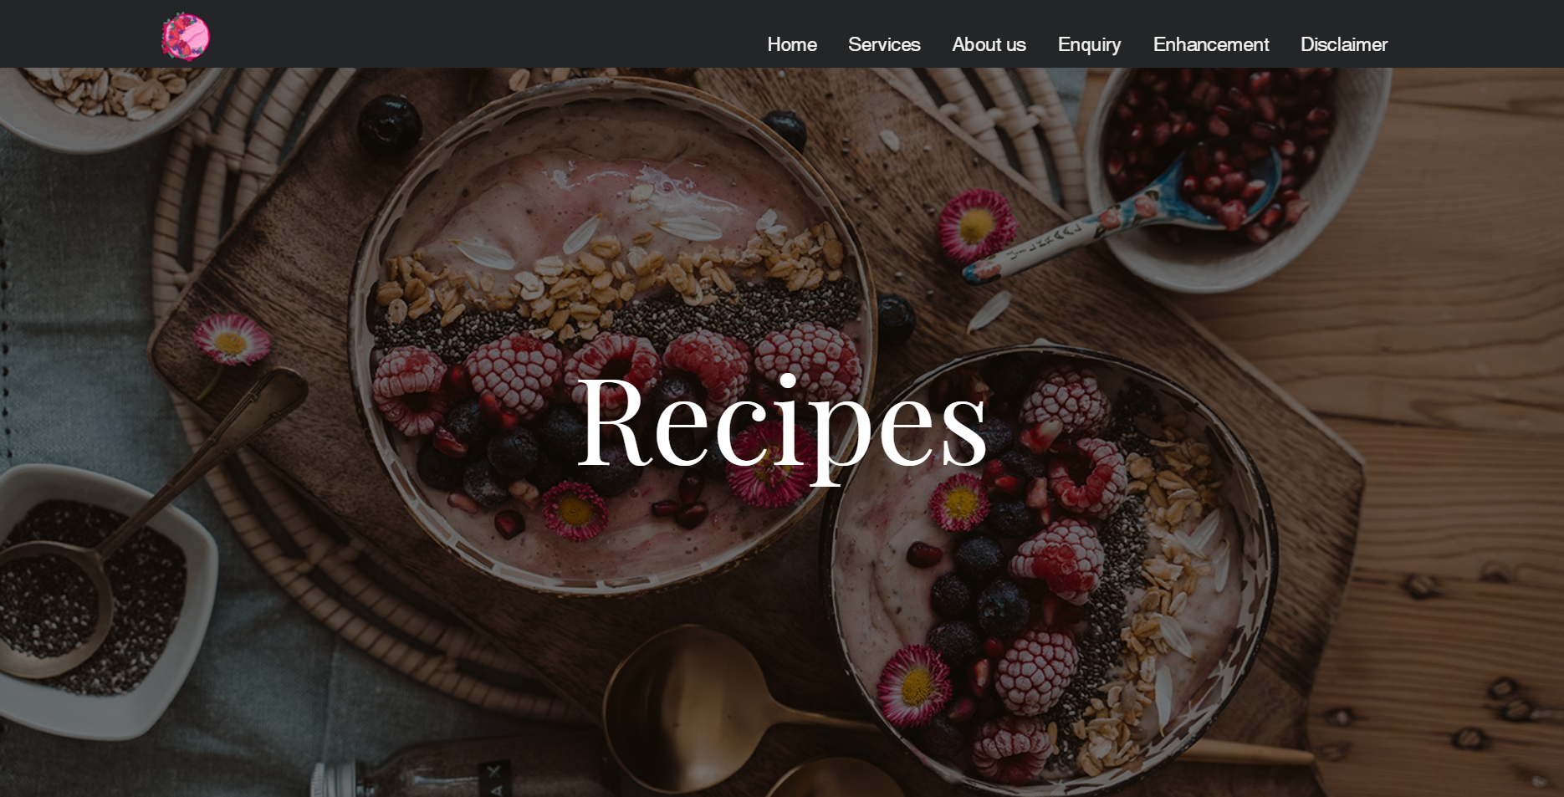

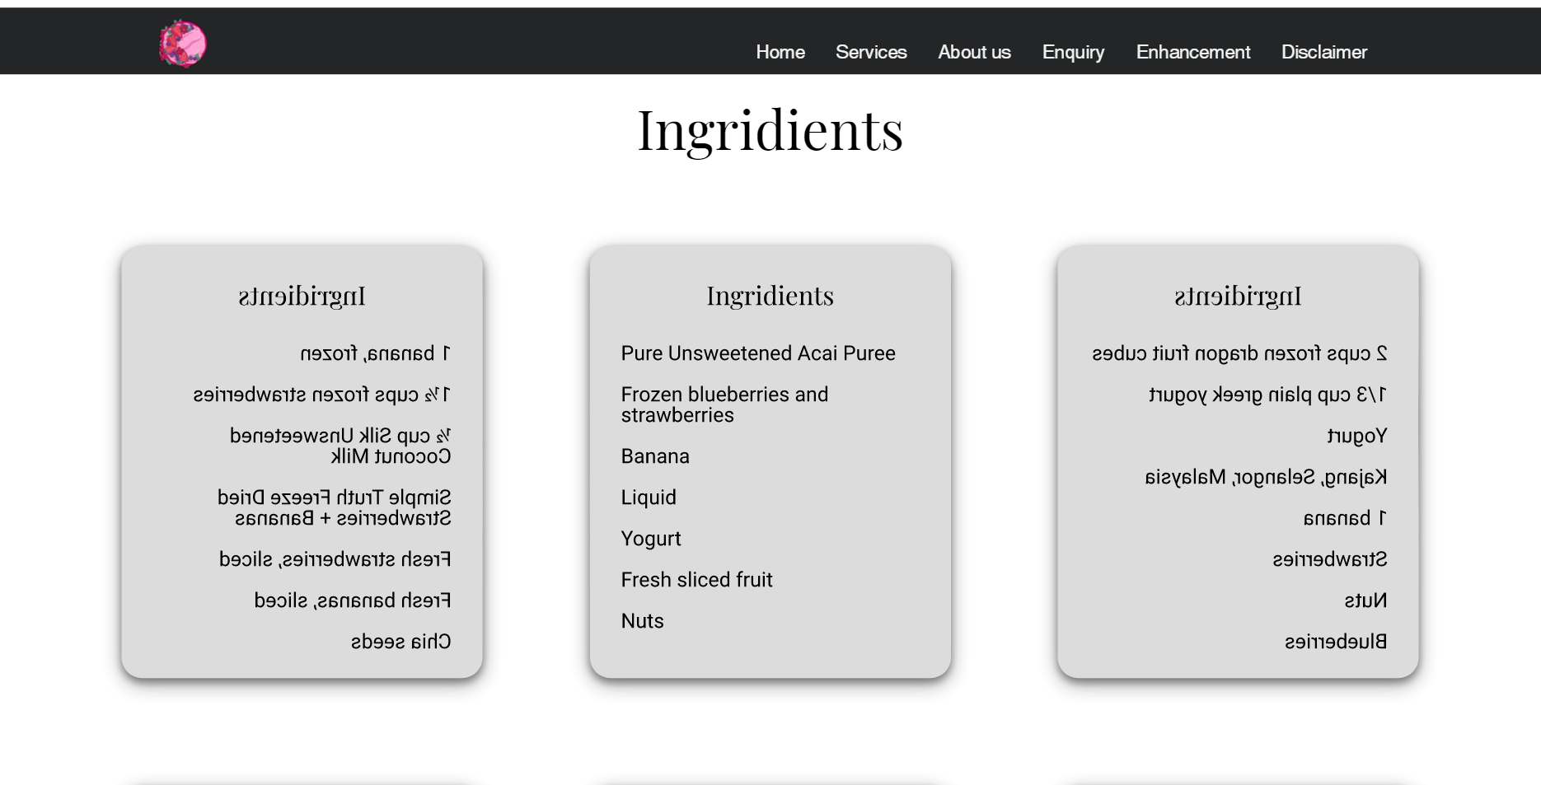

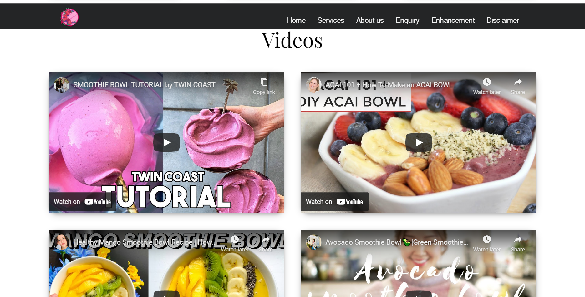

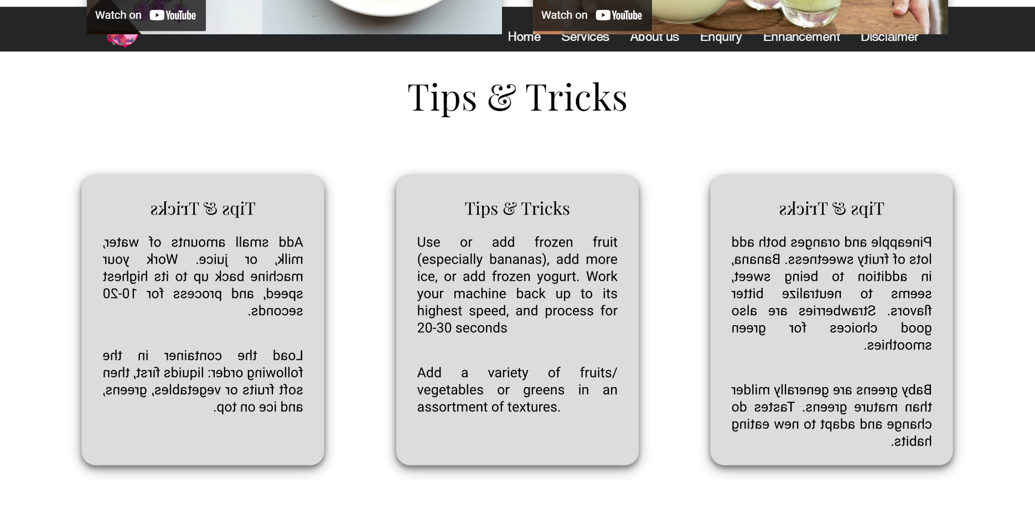

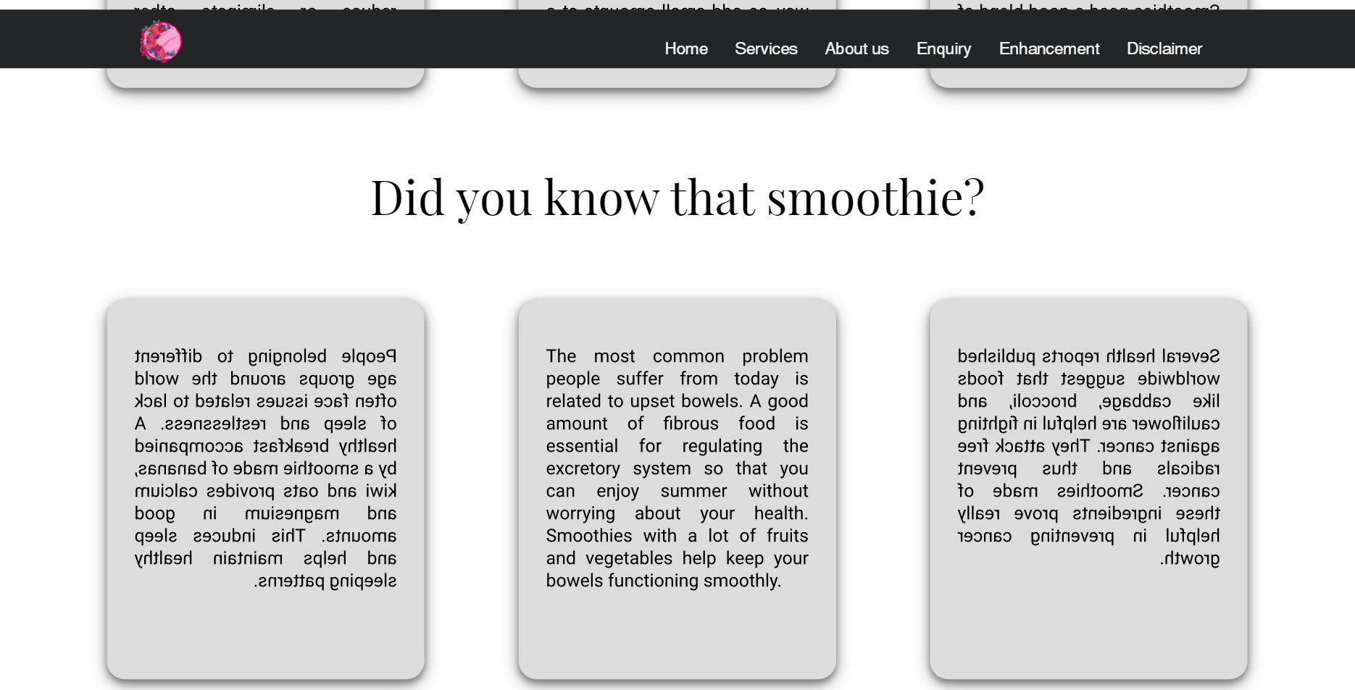

#### 1.3.1.4 Booking

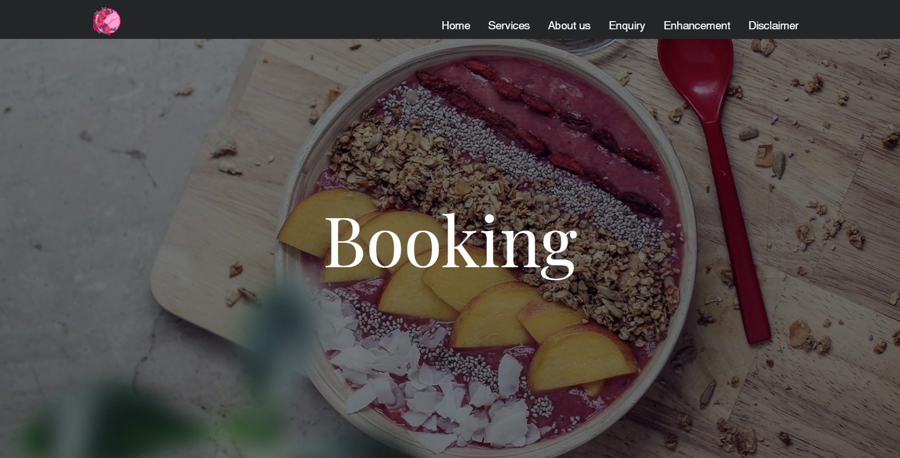

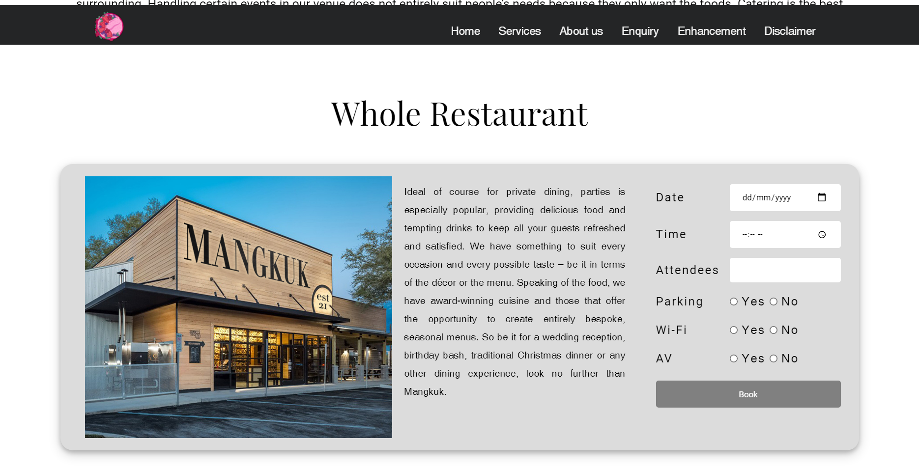

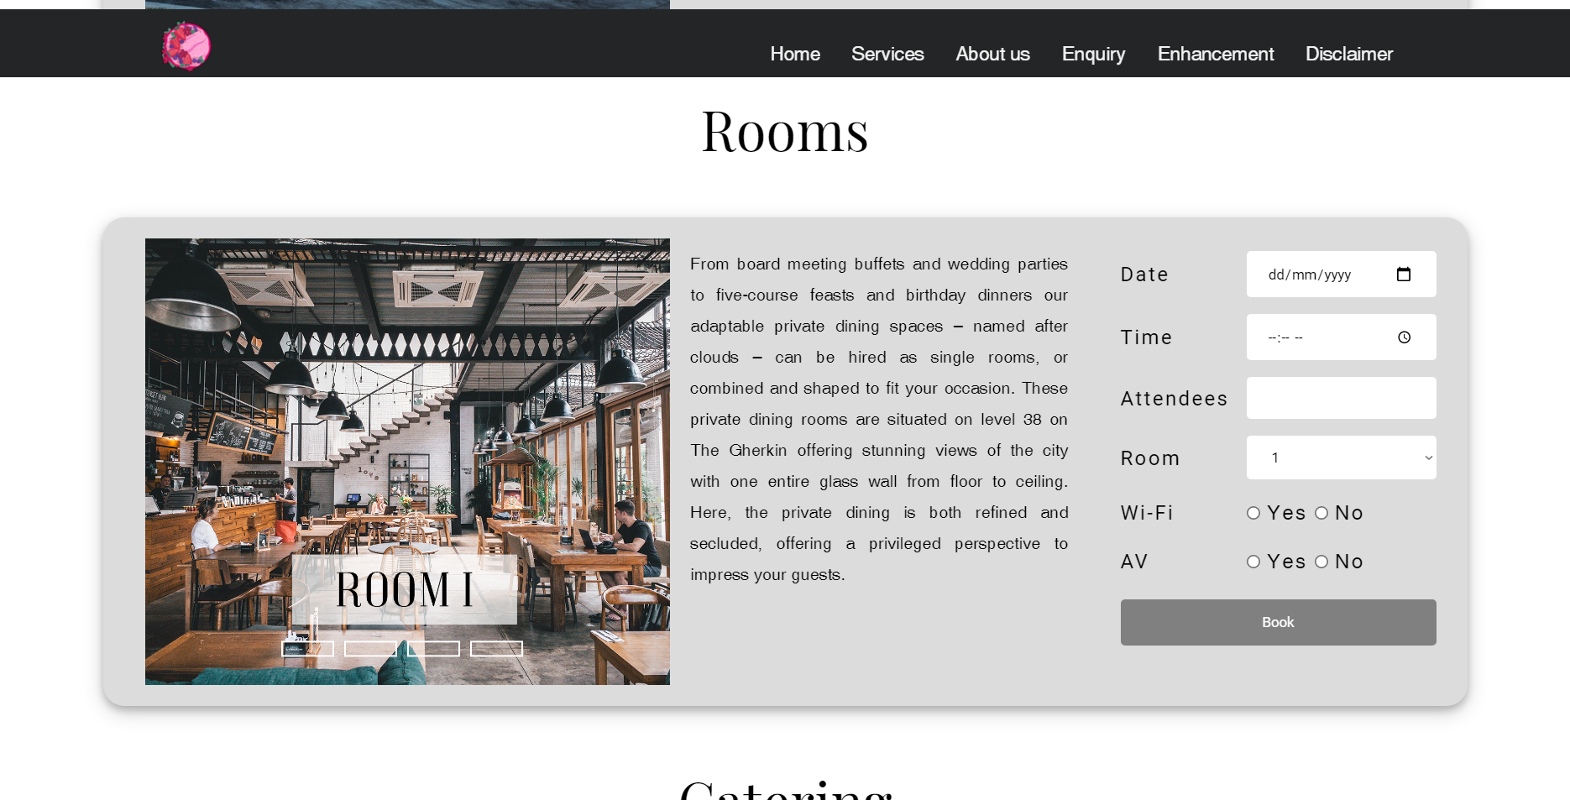

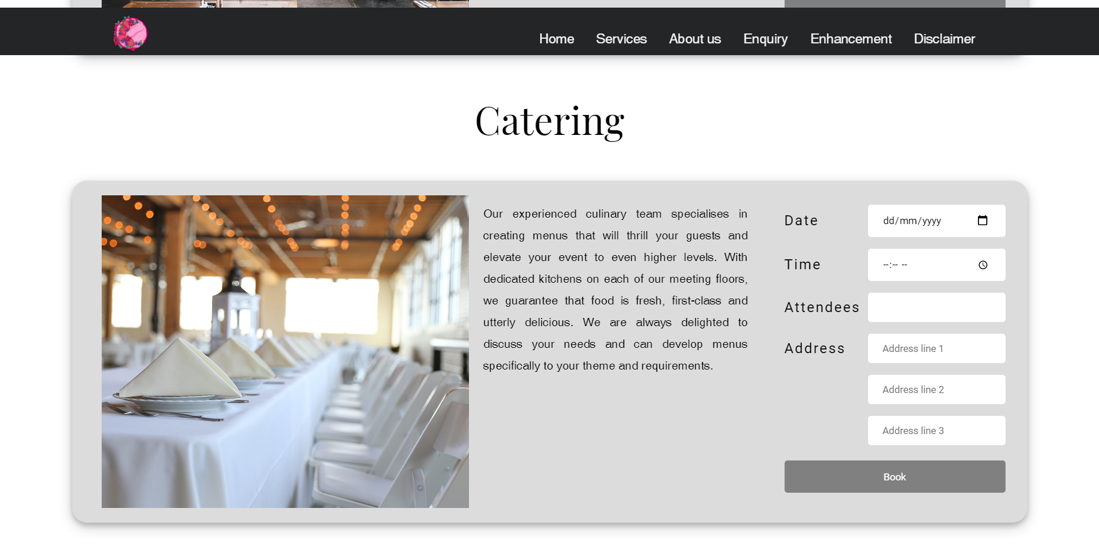

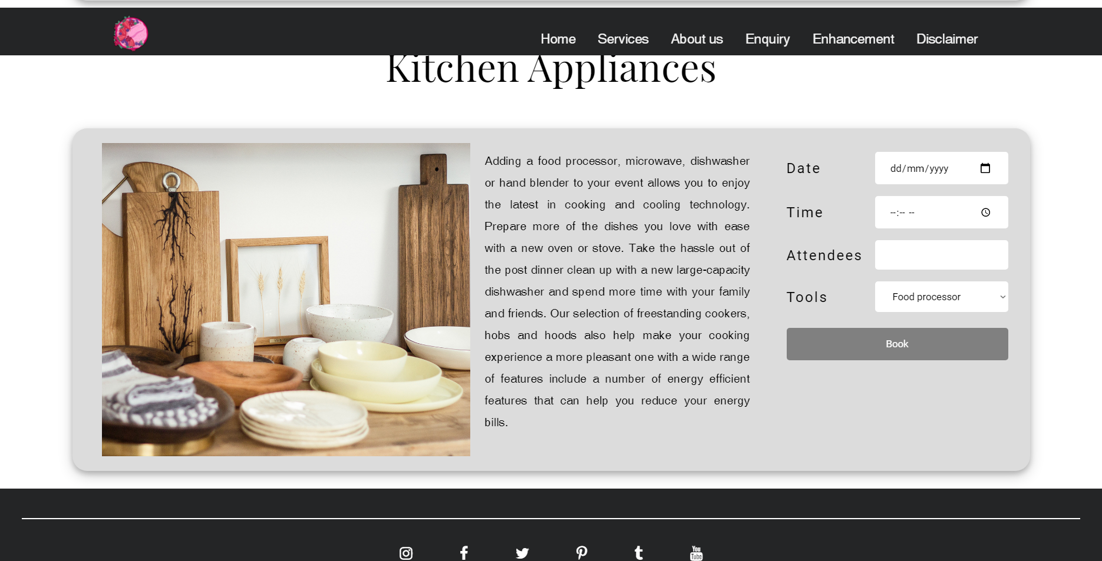

#### 1.3.1.5 Jobs

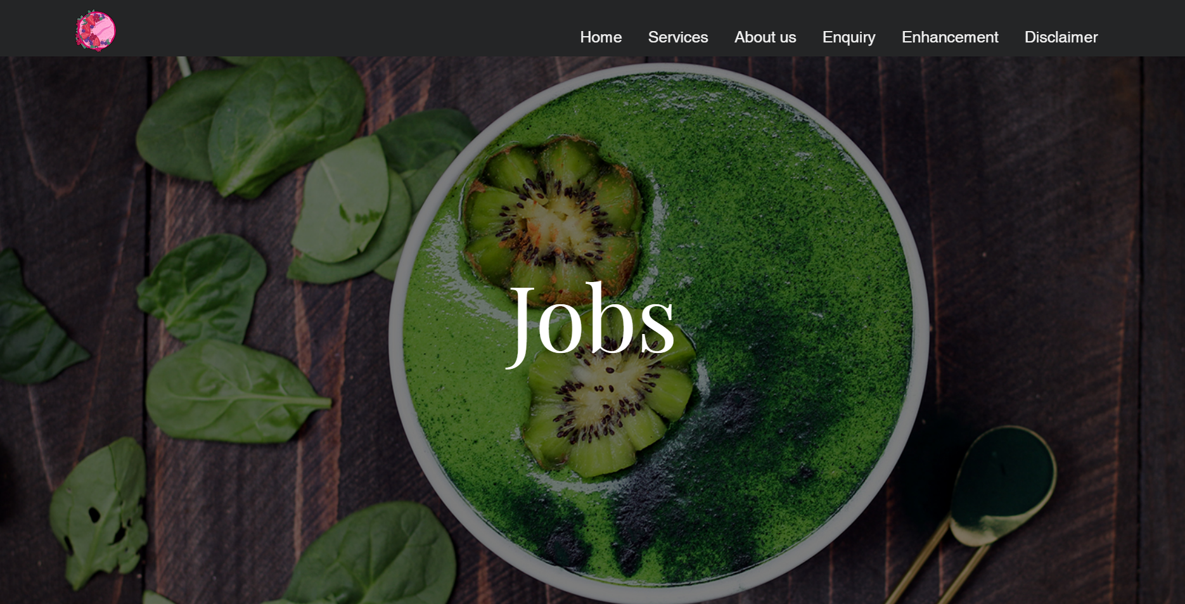

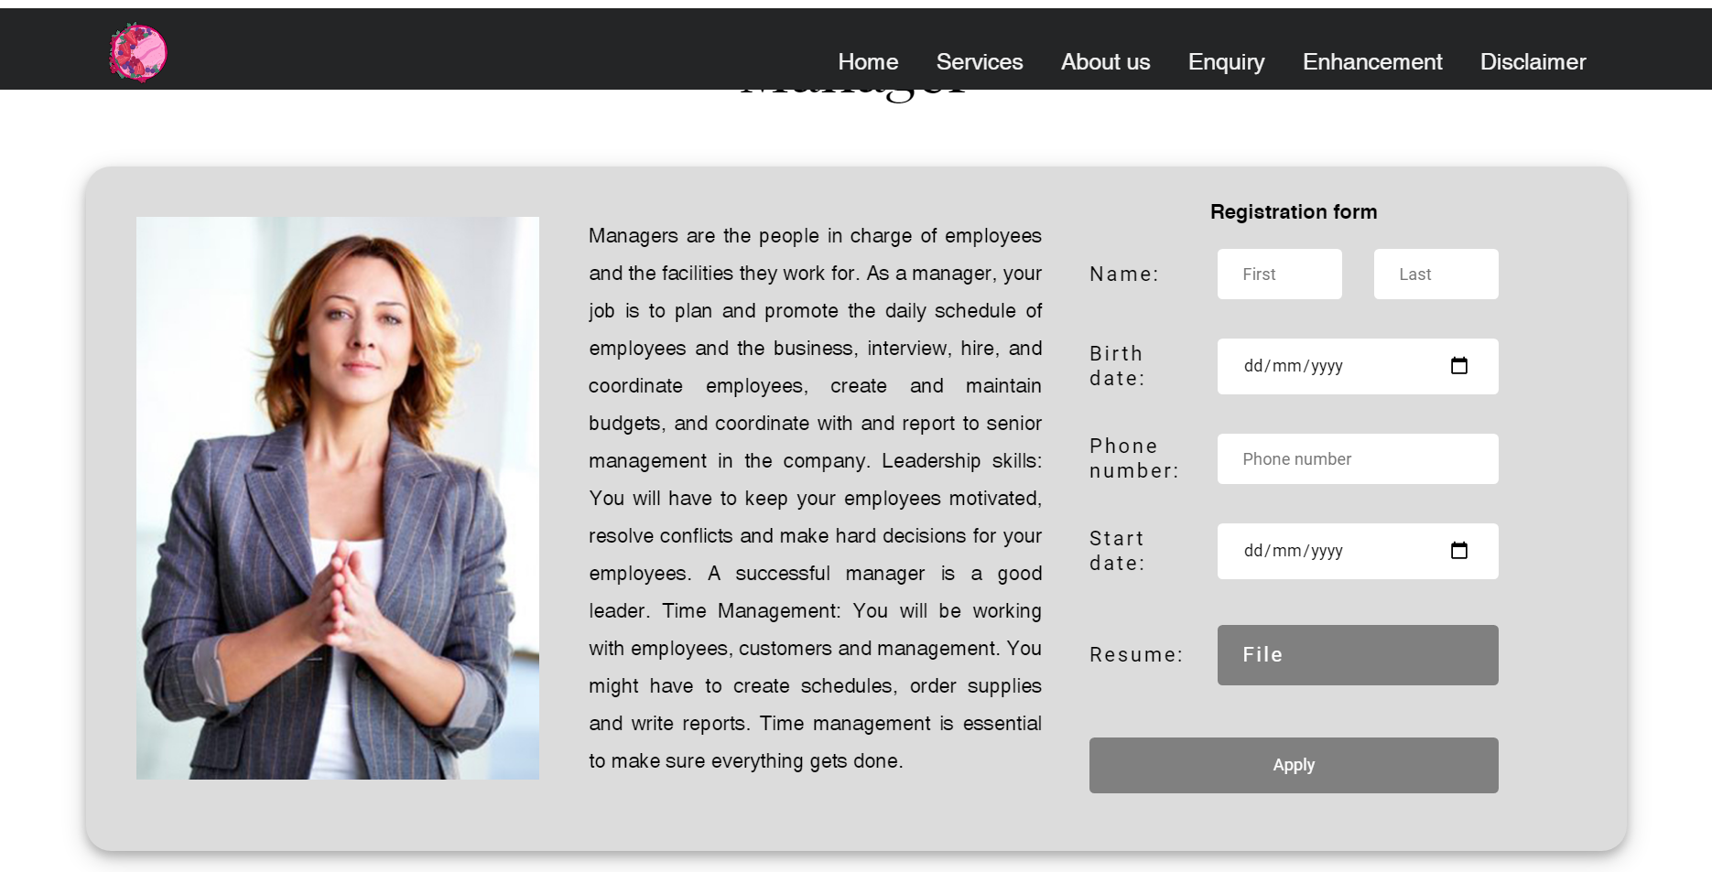

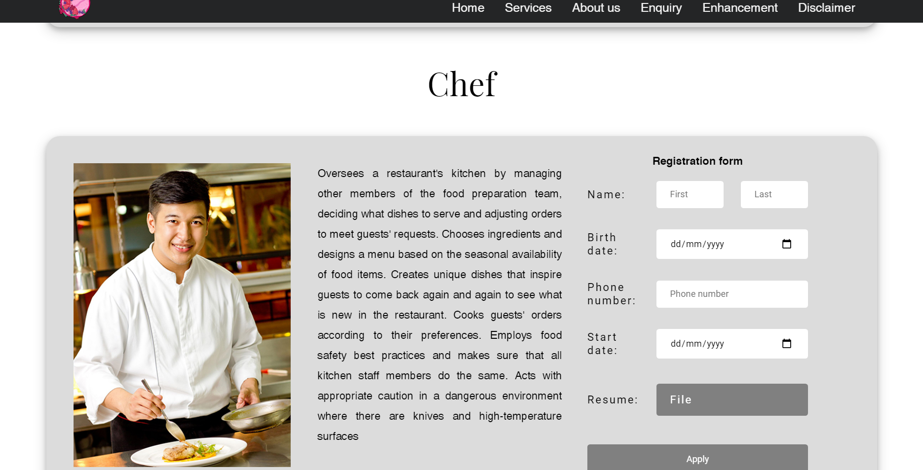

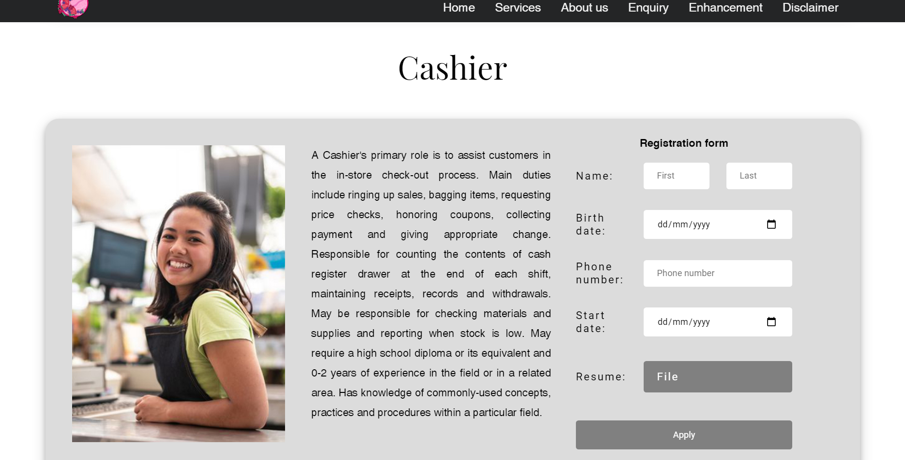

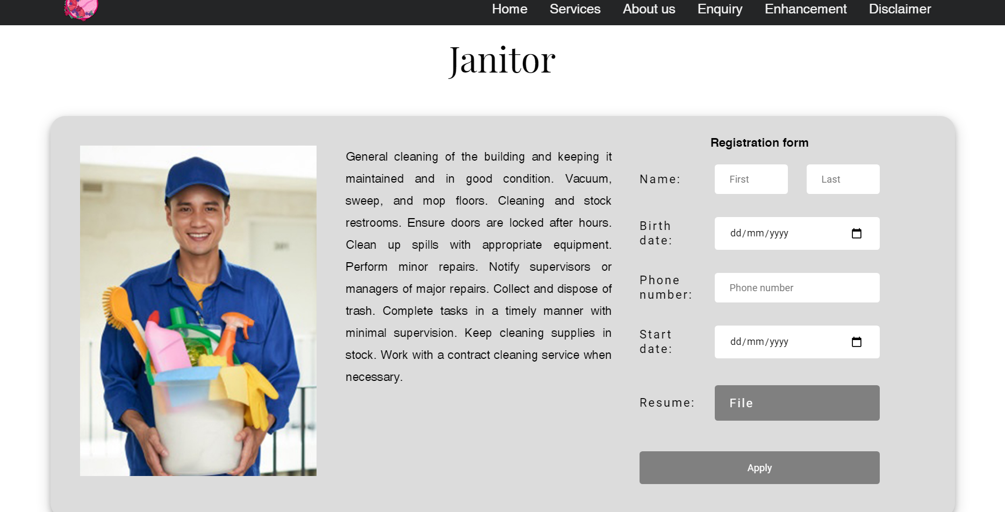

#### 1.3.1.6 About Mangkuk

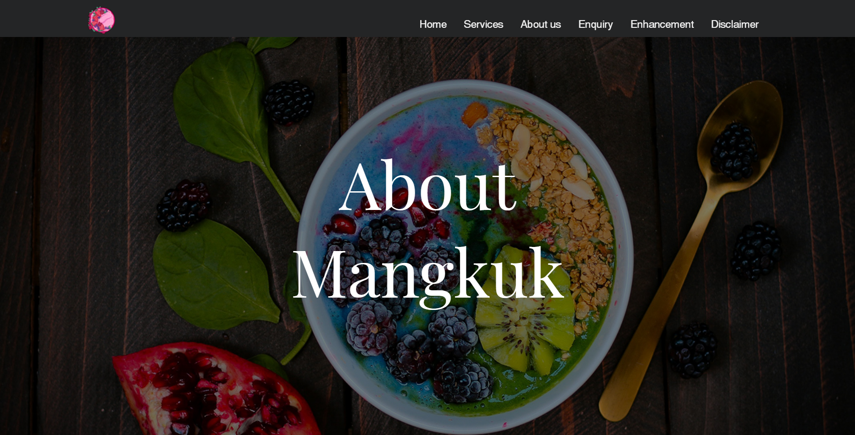

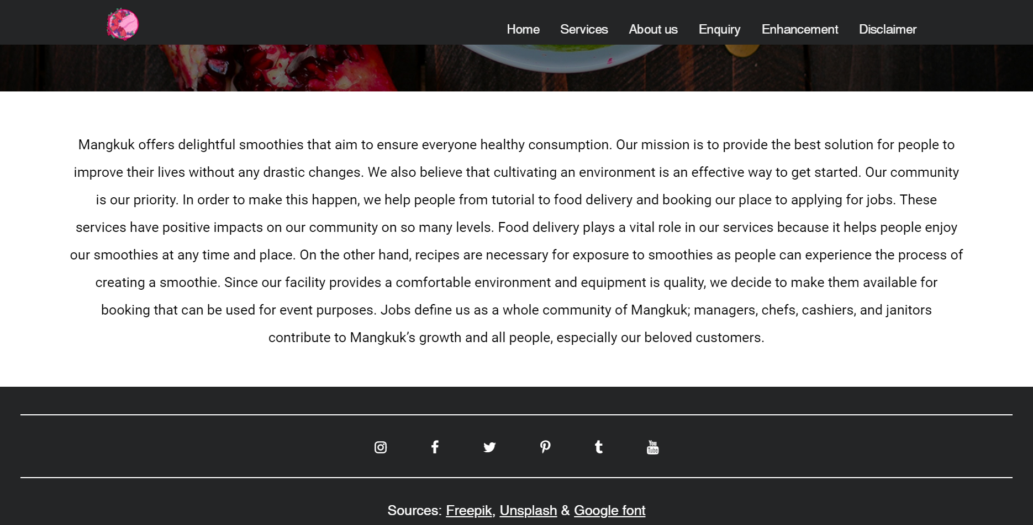

#### 1.3.1.7 About me

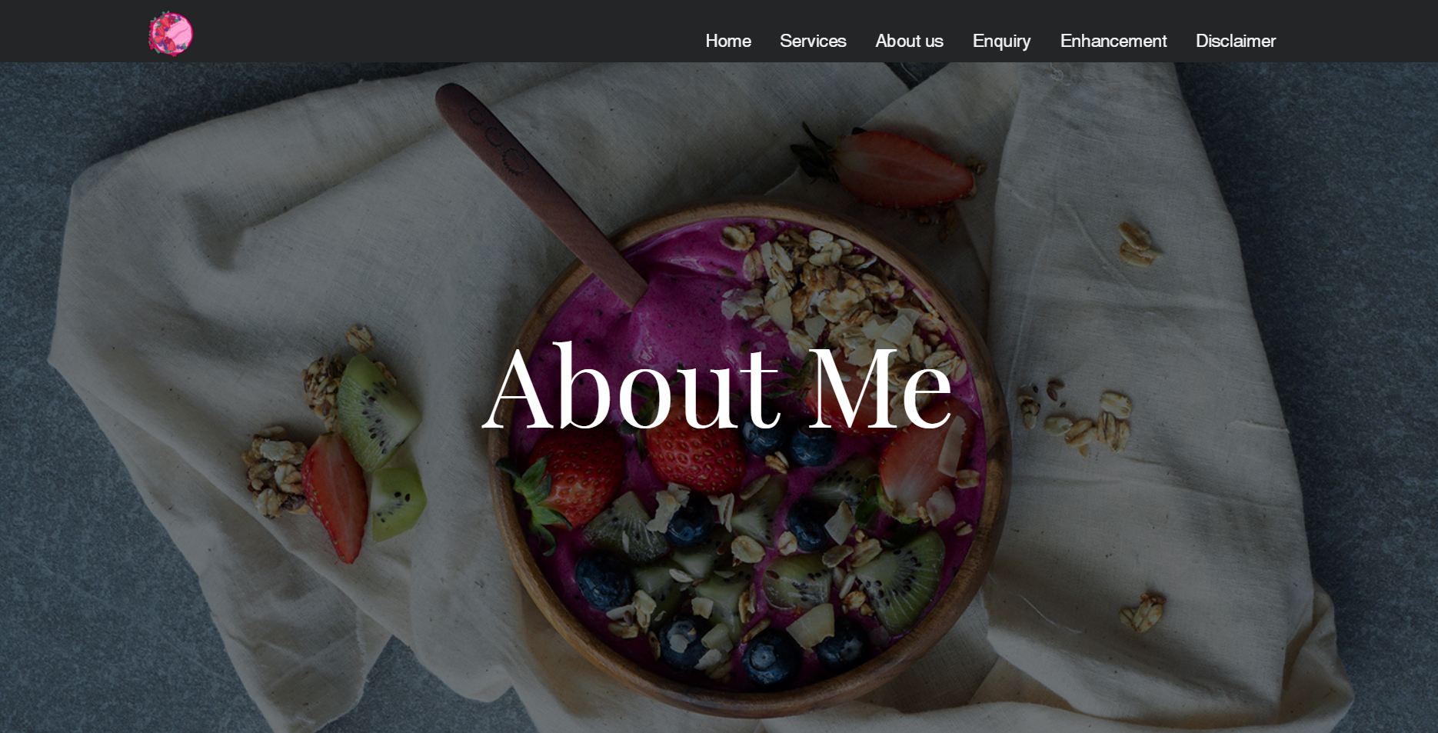

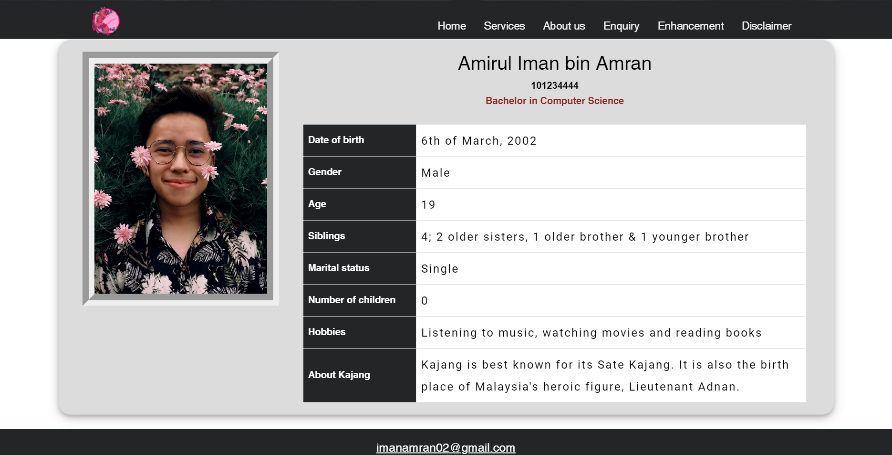

#### 1.3.1.8 Enquiry

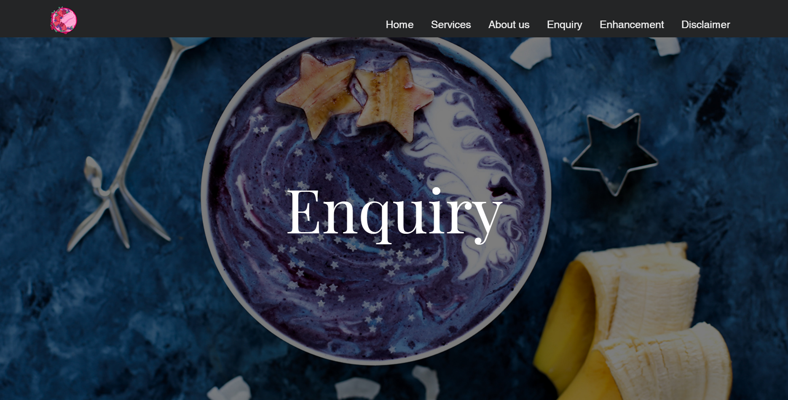

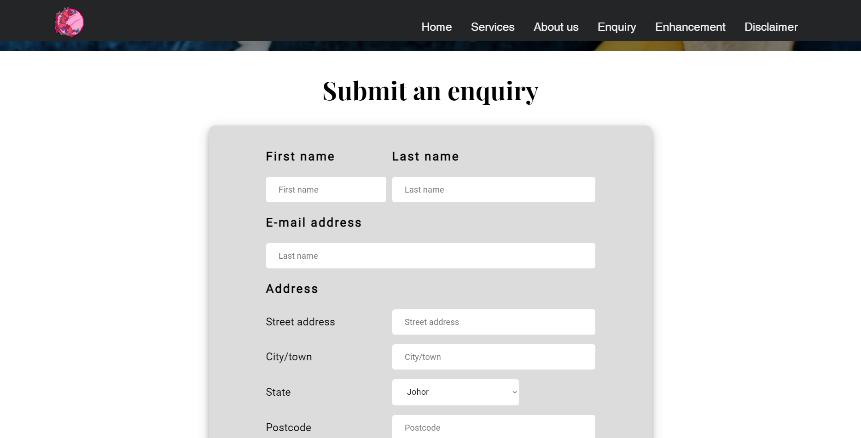

#### 1.3.1.9 Enhancement

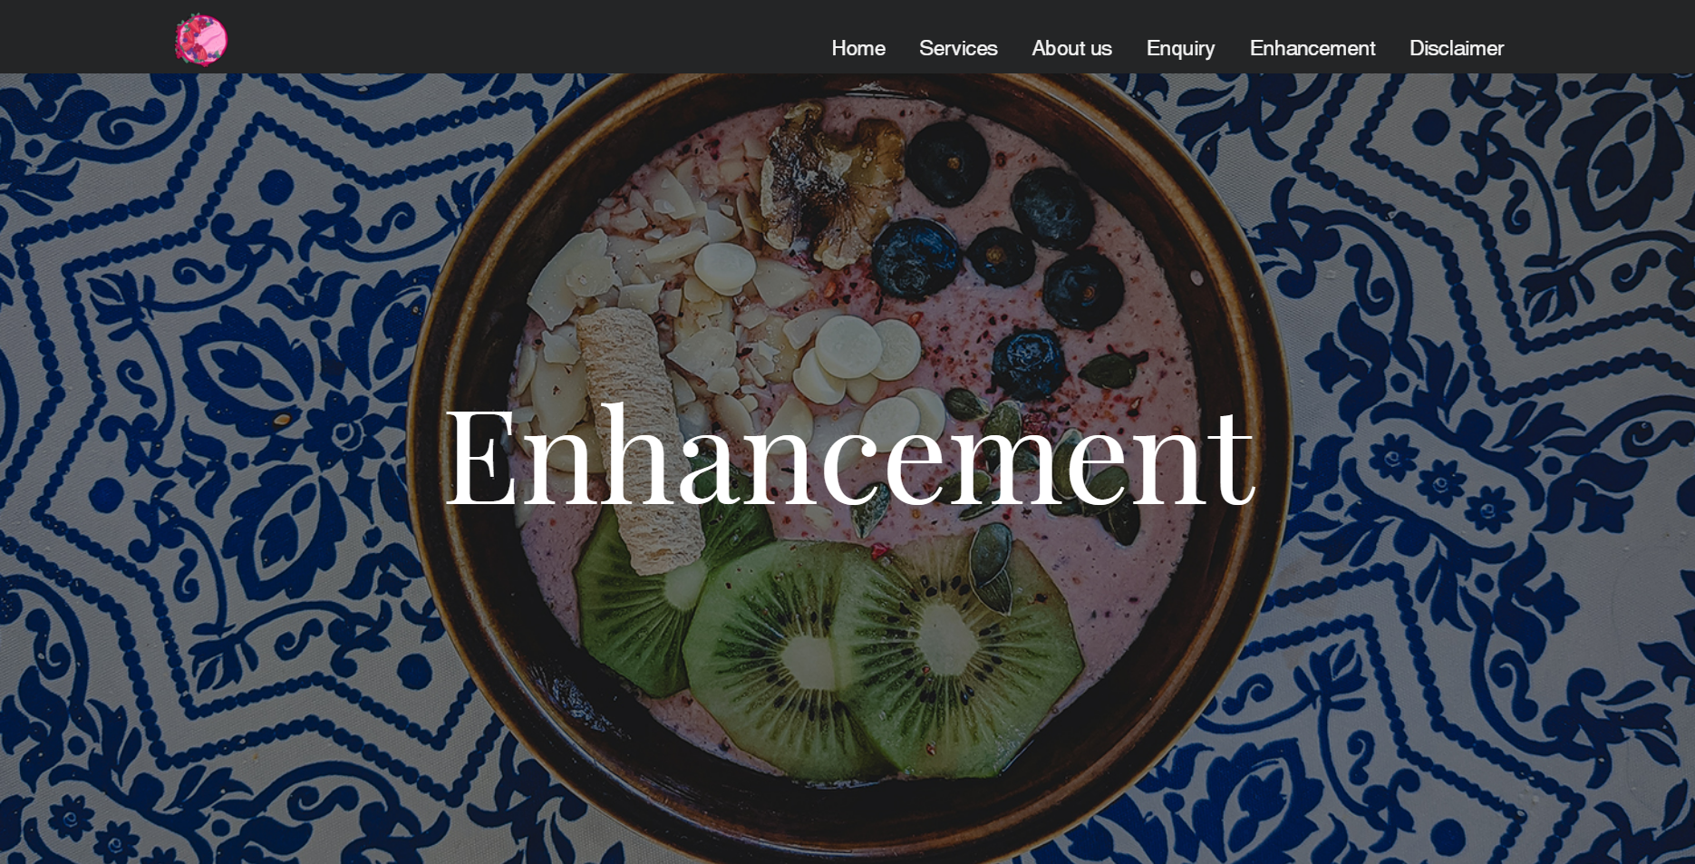

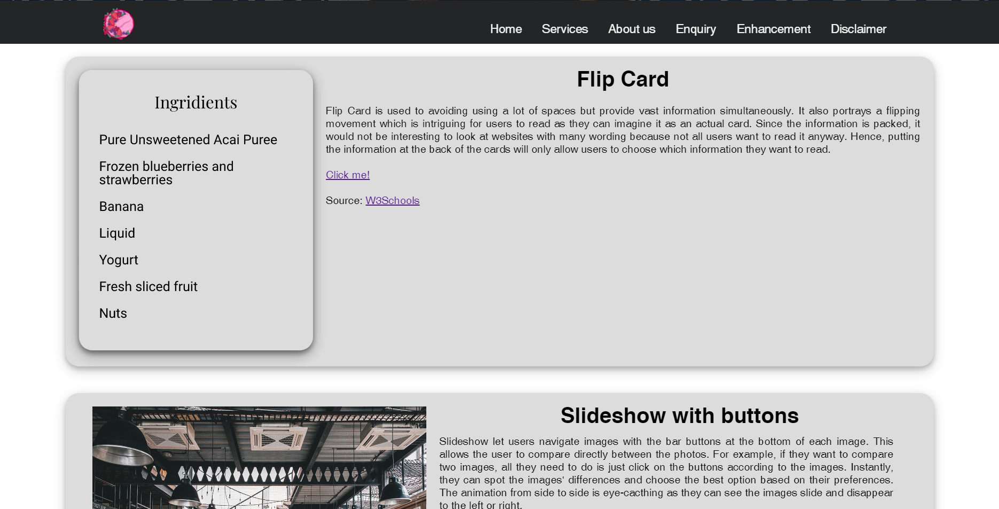

#### 1.3.1.10 Disclaimer

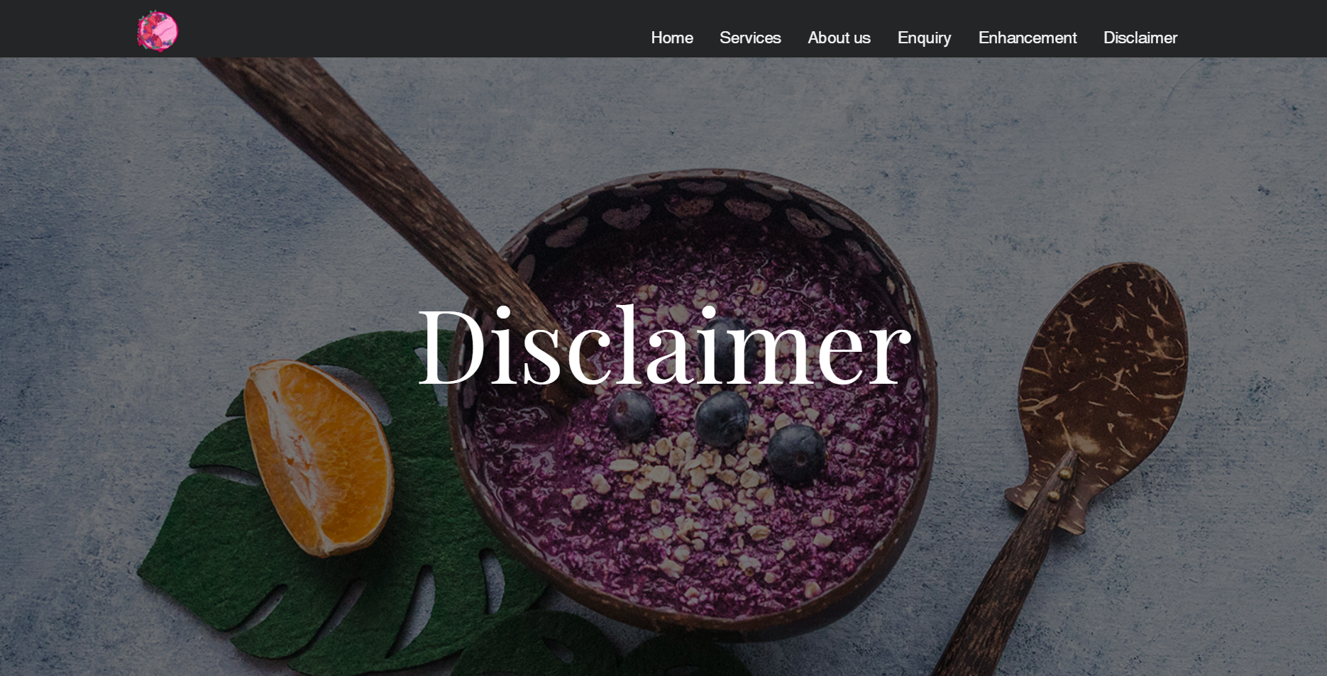

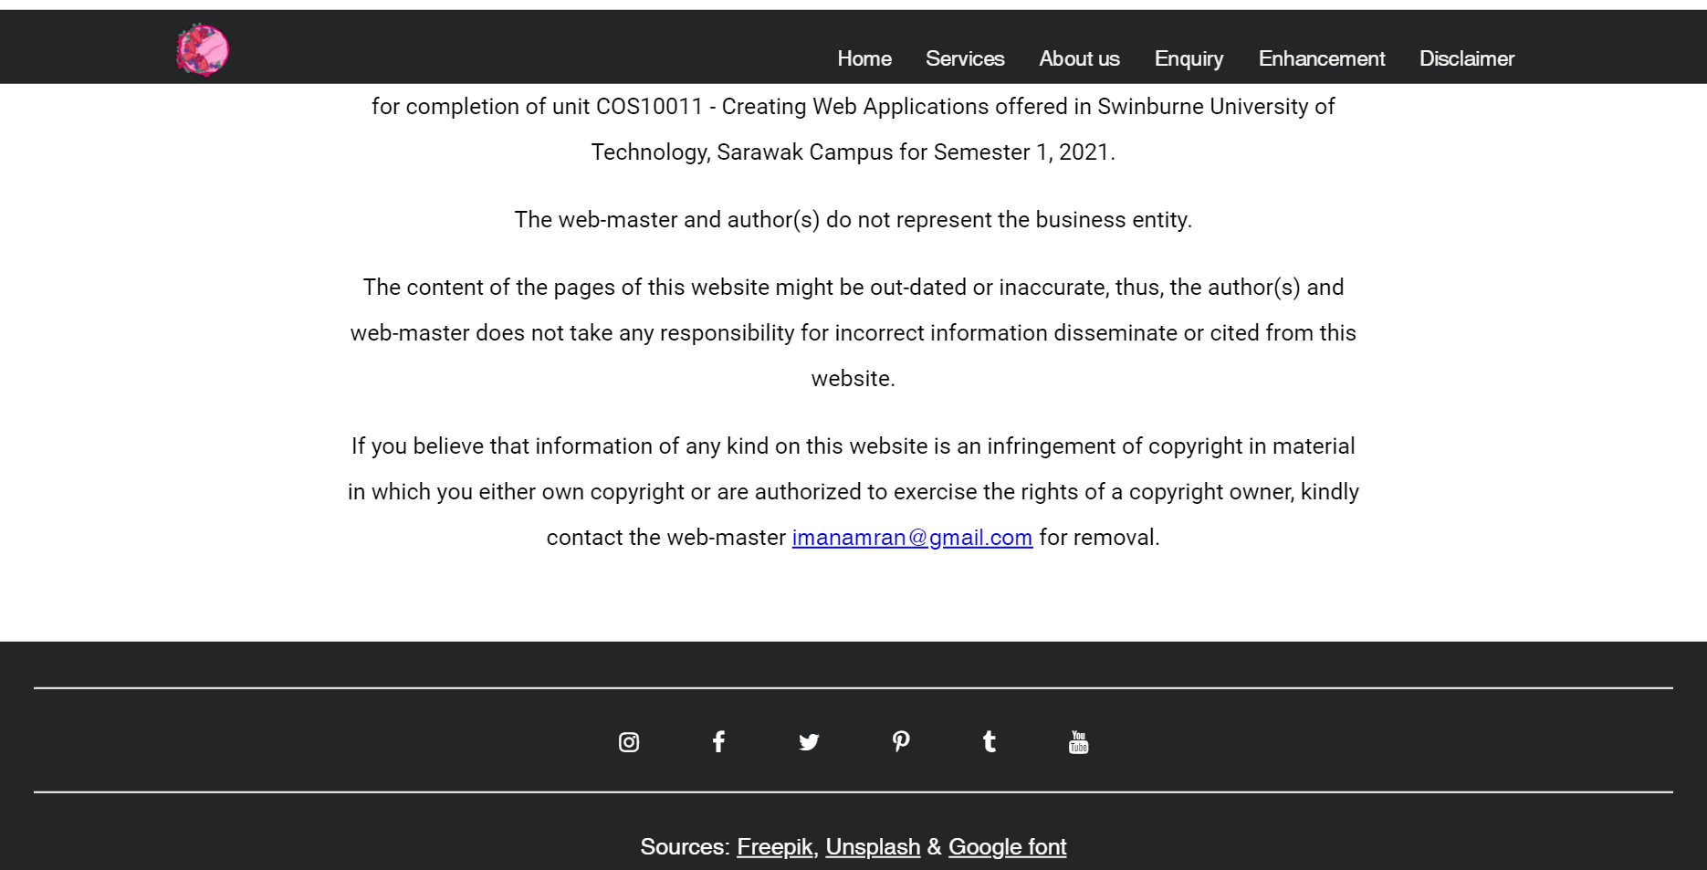

#### 1.3.1.11 Mobile view

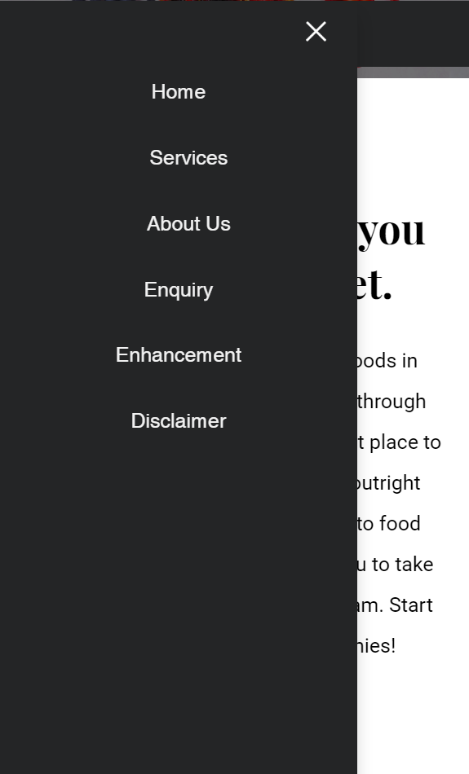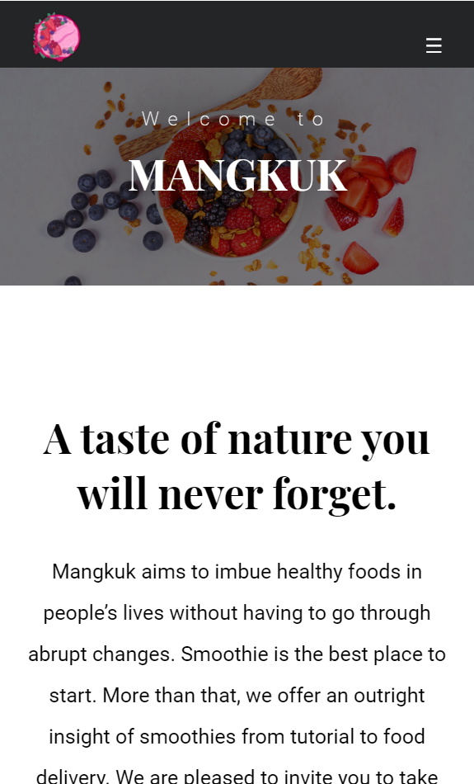

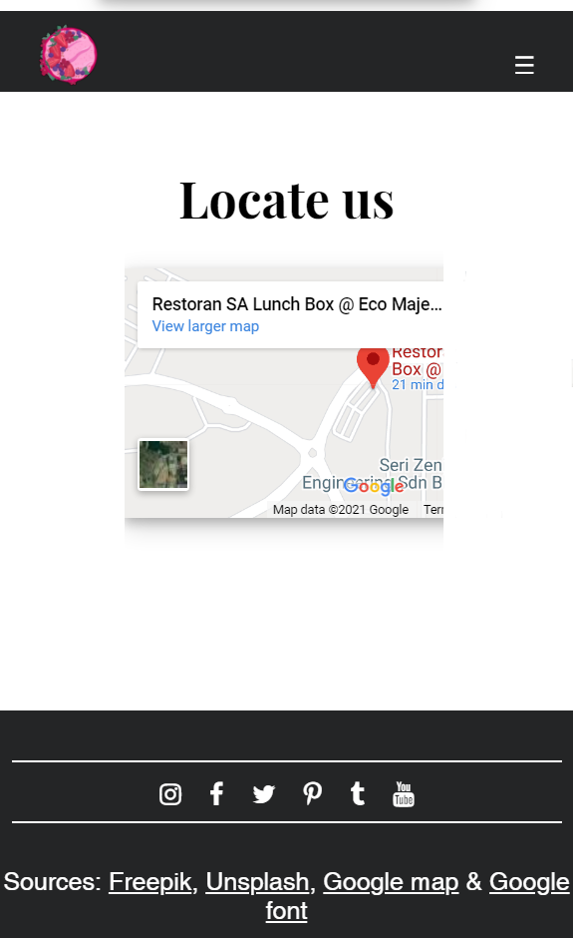

#### 1.3.1.12 Explanation

* Simplicity
* Easy to read
* Not crowded with words
* Consistency throughout all pages
  + Consistent type of images
  + Consistent Navigation
  + Colour scheme (Black, Grey & White)
  + Same typography
* Easy to navigate
* Mobile friendly
* White spaces to reduce complexity and increase readability
* Responsive design
* Clean design

### 1.3.2 Enhancements

#### 1.3.2.1 Flip Cards

Flip Card is used to avoiding a lot of spaces but provide vast information simultaneously. It also portrays a flipping movement which is intriguing for users to read as they can imagine it as an actual card. Since the information is packed, it would not be interesting to look at websites with many wording because not all users want to read it anyway. Hence, putting the information at the back of the cards will only allow users to choose which information they want to read.

#### 1.3.2.2 Slideshow with buttons

Slideshow let users navigate images with the bar buttons at the bottom of each image. This allows the user to compare directly between the photos. For example, if they want to compare two images, all they need to do is just click on the buttons according to the images. Instantly, they can spot the images' differences and choose the best option based on their preferences. The animation from side to side is eye-catching as they can see the images slide and disappear to the left or right.

#### 1.3.2.3 Google Map

Google map allows users to locate the restaurants' location so that they can get the direction to Mankuk restaurant. It also can grab users' attention to know more about the restaurant location as they can navigate the path to go to the restaurant from their current location. This Google map helps users to find the nearest restaurant that they can go to. They can also see the restaurant venue from the top, which is essential for the events' area planning if they consider booking the whole restaurant.

# Assignment 2

## 2.1 Description

### 2.1.1 Validation

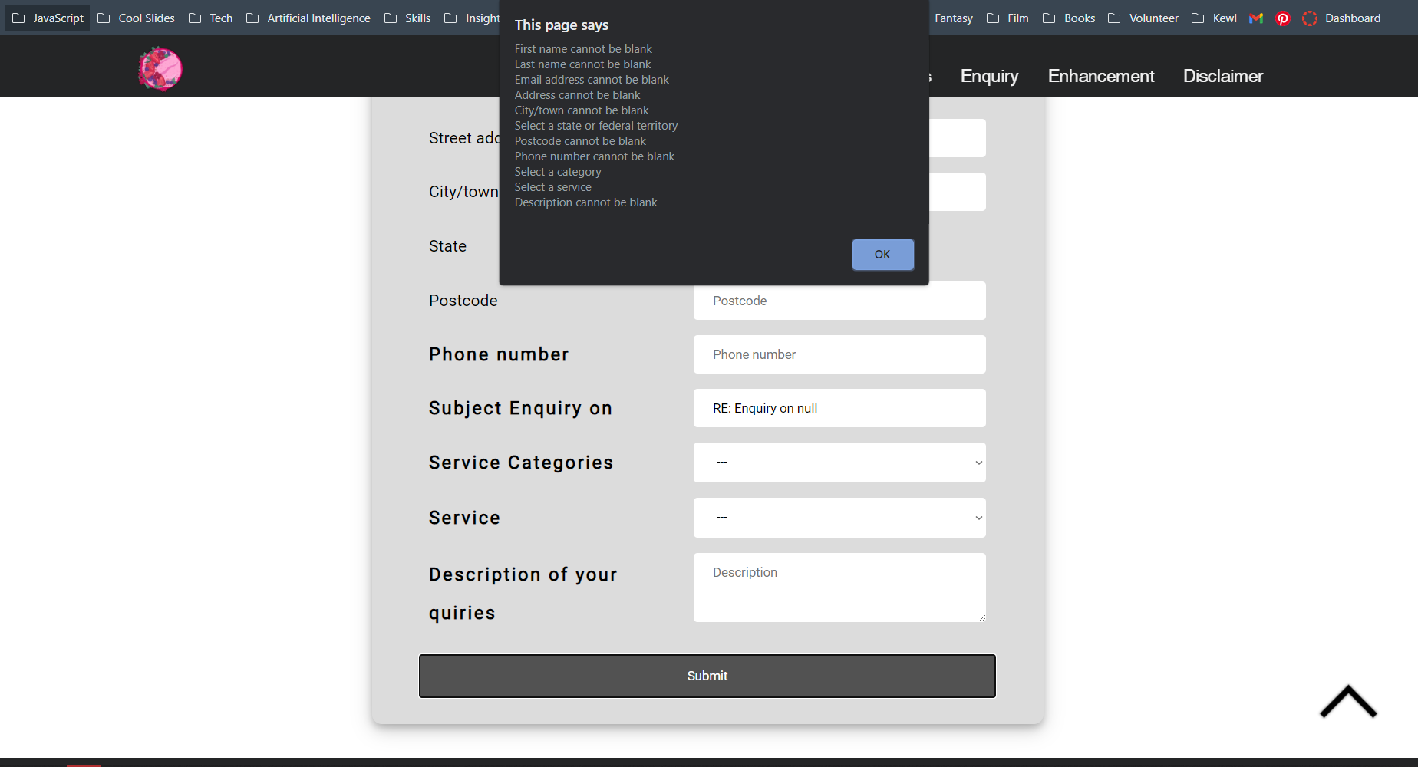

Each input has a JavaScript function that check the input typed by the users based on the specifications to ensure that it is inserted correctly. For example, the users can only enter numerical and not alphabetical characters for the phone number form.

**JavaScript explanation**

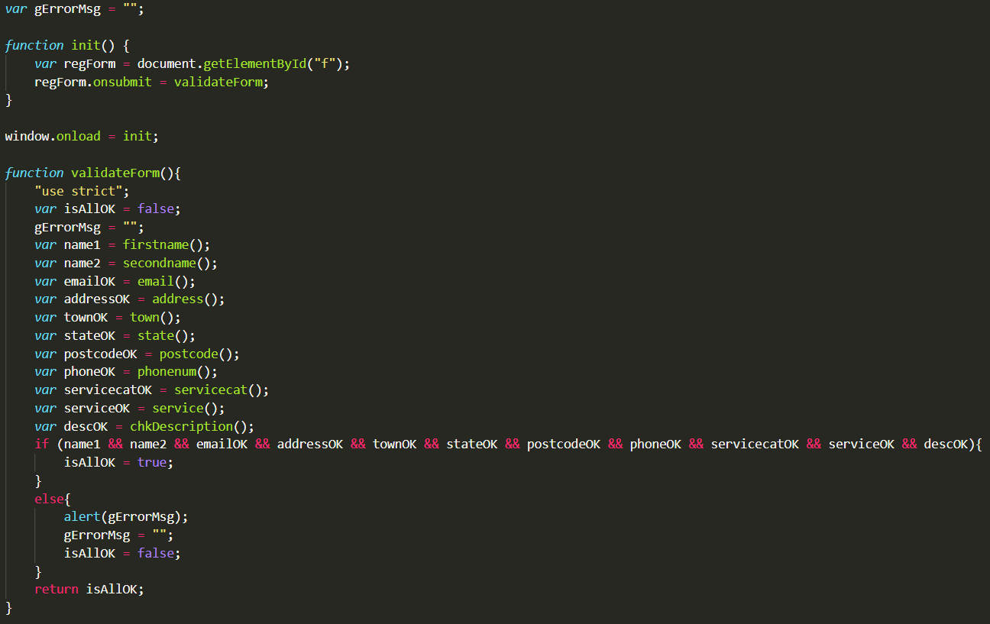

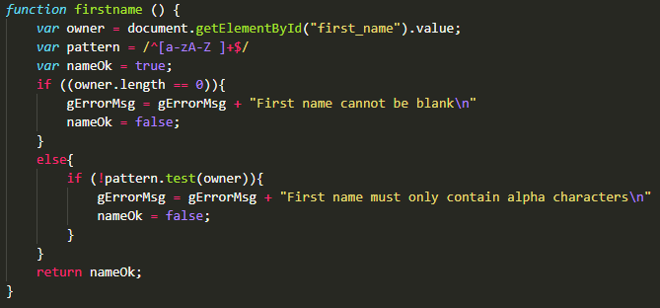

First of all, *gErrorMsg* is a variable with a “ “ string value assigned to it. This is useful for the other functions to append messages later on.

Next, is *innit* function that will receive a data from an ID element on HTML which is ‘f’ that is embedded inside the form element, <form id=”f”></form>. It will onload itself first. Whenever the user click submit, the function will then calls *validateForm* function to check all the inputs inserted by the user.

*validateForm* function will receive data from all the functions inside it. For example, *firstname* function will append a message to the *gErrorMsg* variable and send a boolean value (true/false) back to the *validateForm* function. The *firstname* function purpose is to check whether the input is correct or not using if else conditions. The message that is appended to *gErrorMsg* variable is vary depending to the condition output.

Same goes to the other form functions.

### 2.1.2 Data Transfer – between pages

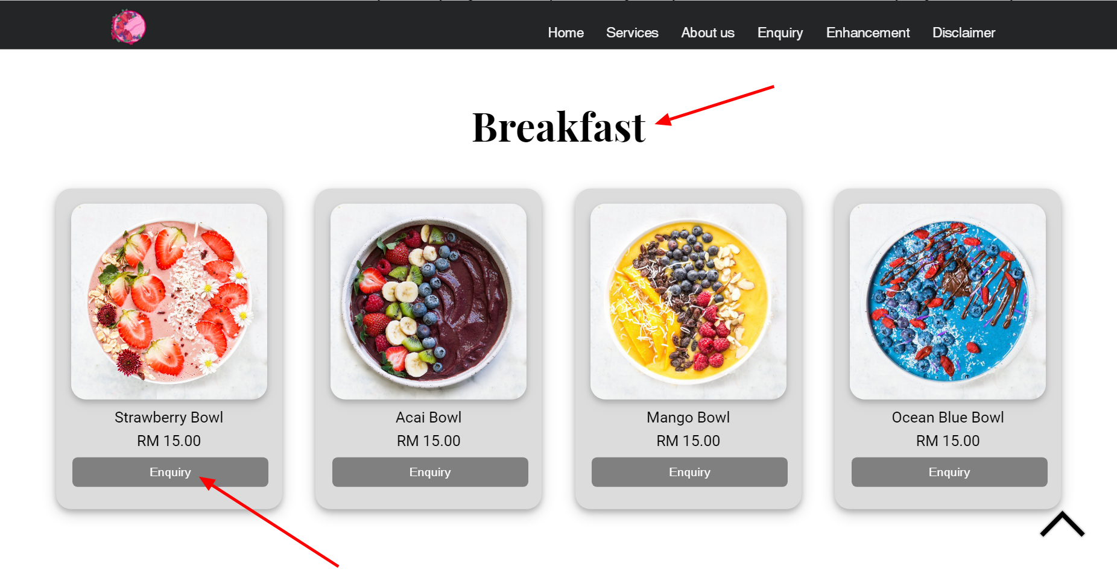

Food delivery page

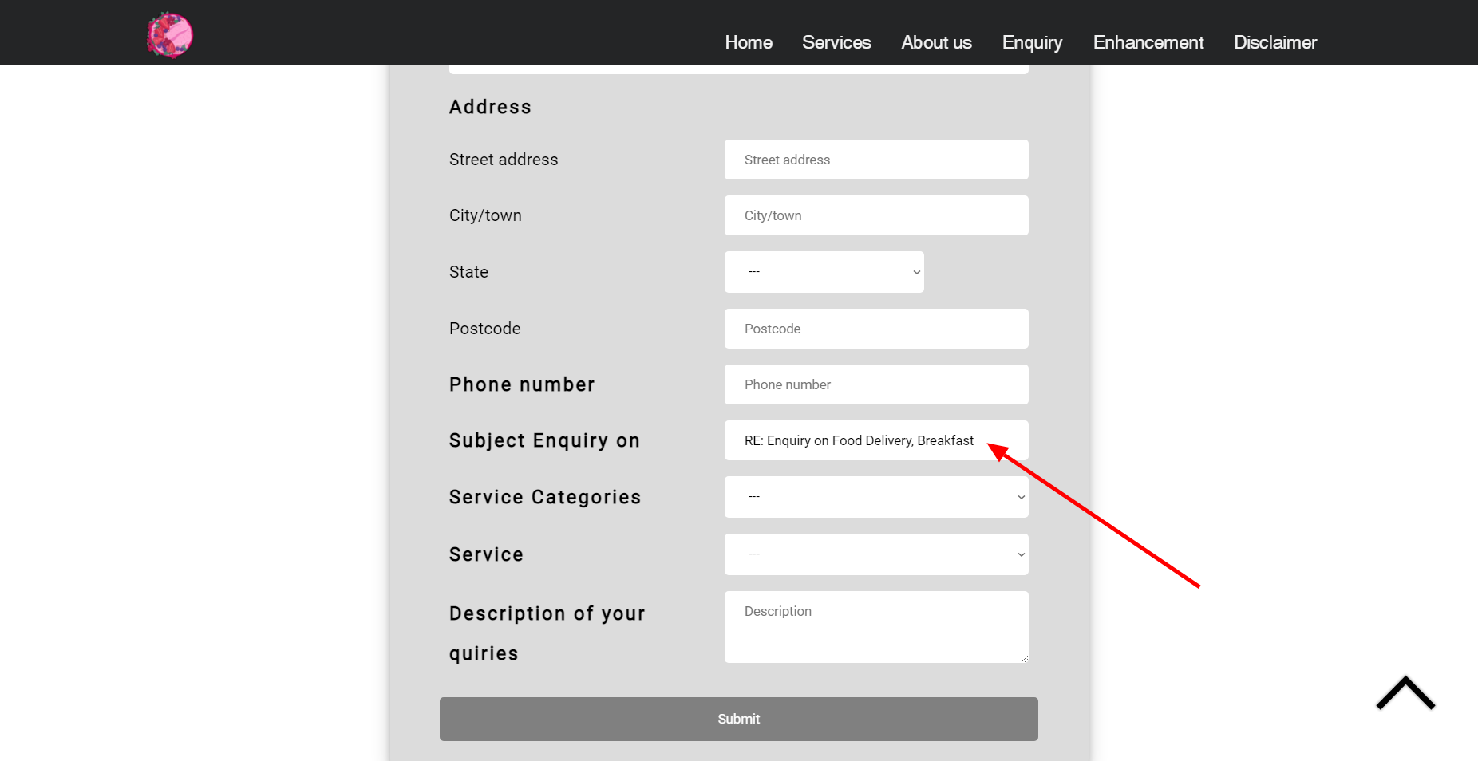

Whenever the users click the enquiry button, it will go to the enquiry page alongside the stored data. Based on the picture, the **‘Breakfast’** products are under the **‘Food delivery’** service, so when the users click the enquiry button on the product page, it will store **‘Food delivery, Breakfast’** as a data. After that, the data will then be transferred and pasted at the **‘Subject Enquiry on’** form as the output on the enquiry page.

**JavaScript explanation**

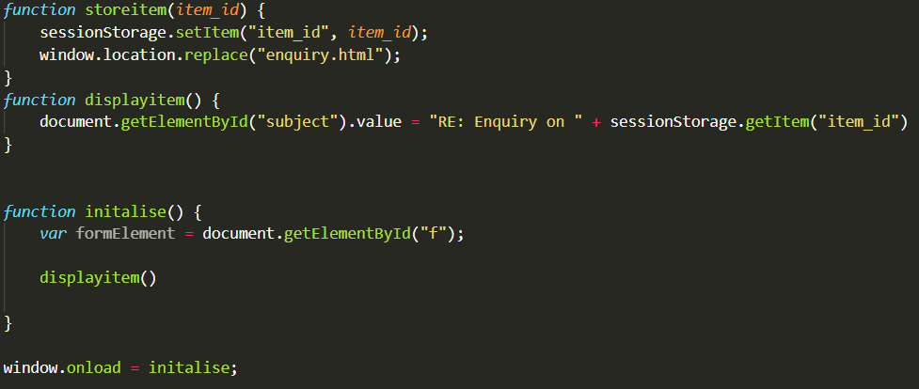

*storeitem* function will first receive (assign to “item_id”) and store (sessionStorage) a string value from the onclick script on HTML. Then, it brings the user to the enquiry page along with the data.

*displayitem* function will retrieve the value from sessionStorage.getItem(“item_id”) and append to the string, forming a message/ sentence (string value). Then, it pastes the output on the element that has an ID of “subject”.

### 2.1.3 Data Transfer – within pages

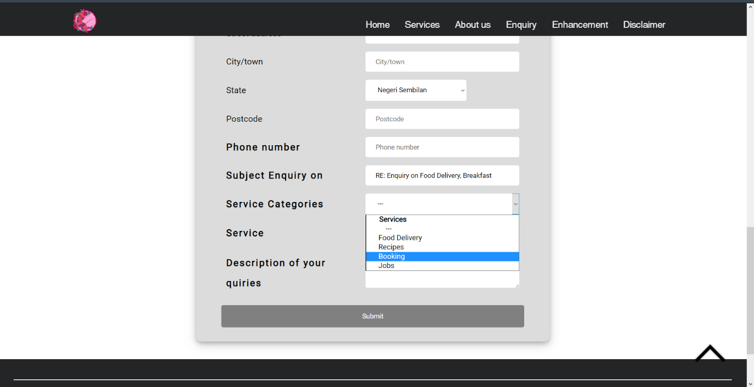

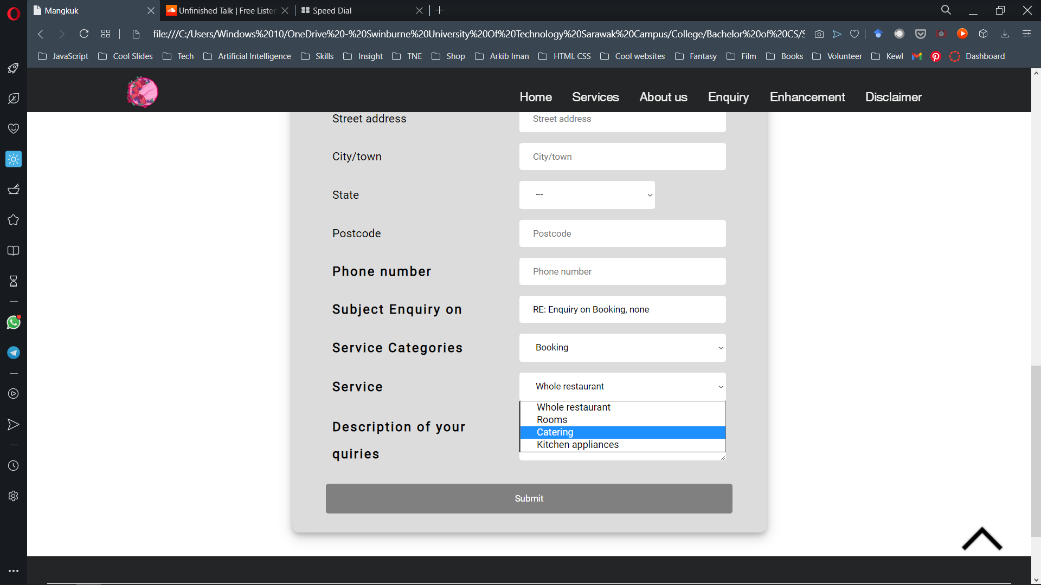

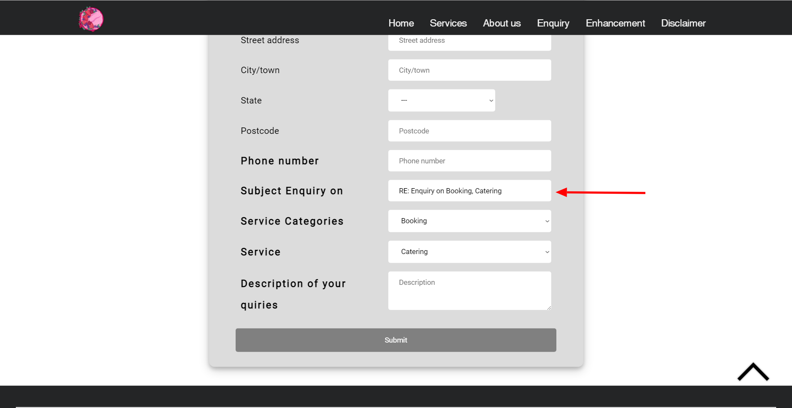

Another way, when the users are not on the services/products page but on the enquiry page instead, this is where transferring data within the page comes to play. In this case, as the user selects the **‘Booking’** service, the data will be transferred to the from beneath it which is **‘Service’**. Using the data, the **‘Service’** will then provide options such as **‘Whole restaurant’, ‘Rooms’, ‘Catering’** and **‘Kitchen appliances’**. The **‘Service’** options will change according the data stored at **‘Service categories’**. Different selection at **‘Service categories’** will have different options at **‘Service’**.

**JavaScript explanation**

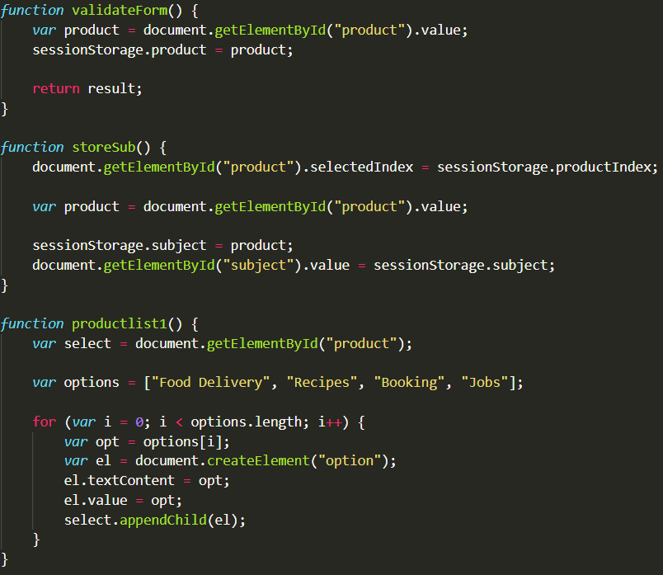

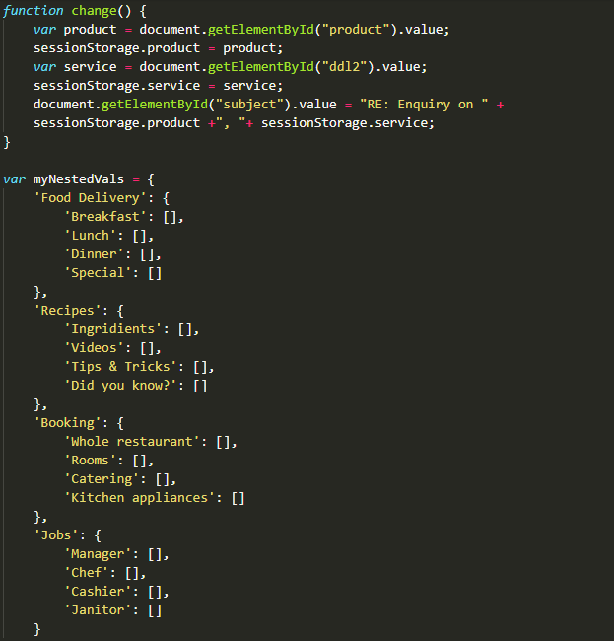



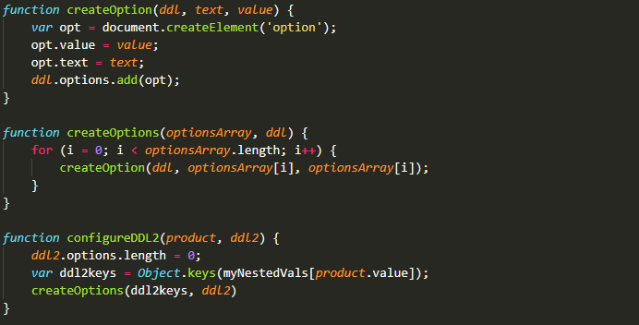

*productlist1* function stores the individual product page which are “Food Delivery”, “Recipes”, “Booking”, “Jobs”. Later, the user will fill the subject field with the value of product based on one of the options. *storeSub* function stores the input from the chosen option of *productlist1* function.

*myNestedVals* variable stores arrays of options according to its main category. *createOption* function receives 3 values and use the ‘option’ element. *configureDDL2* function will then use the data from *myNestedVals* variable.

After that, it changes the value of the session storage according to the new product selected by the user. For example, if the user selects “Food Delivery”, then the options that are available will be “Breakfast”, “Lunch”, “Dinner” and “Special”.

### 2.1.4 Array

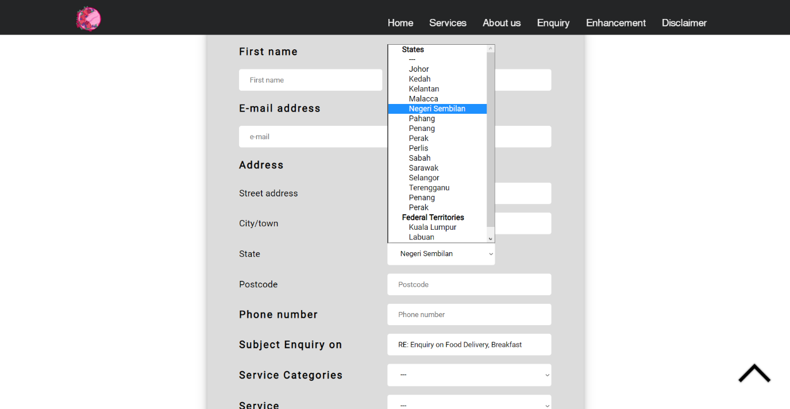

The array that is implemented on this website is used to store states and federal territories data. All the data are stored inside a function that has an array consisting the states and federal territories. From the HTML side, there’s a JavaScript element that calls the function inside the JavaScript file. When the function is called, it will display all the data on the page.

**JavaScript explanation**

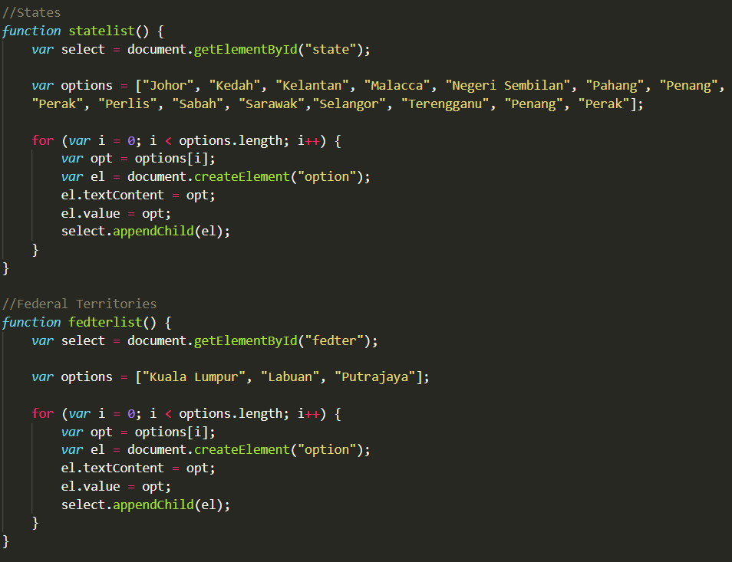

There are two functions which are *statelist* and *fedterlist*. Both of these functions act the same way but just with different contents. *statelist* function contains an array of all states while *fedterlist* function contains an array of all federal territories in Malaysia. They both first get their own ID element which are “state” and “fedter”. A variable named ‘options’ contains all the list.

For loop is used to ensure that the number of lists is correct. *el* variable is equivalent to document.createElement(“option”) that function as to insert to the document. select.appendChild(el) appends the array contains to the list.

## 2.2 End Product

### 2.2.1 Enhancements

#### 2.2.1.1 Slideshow

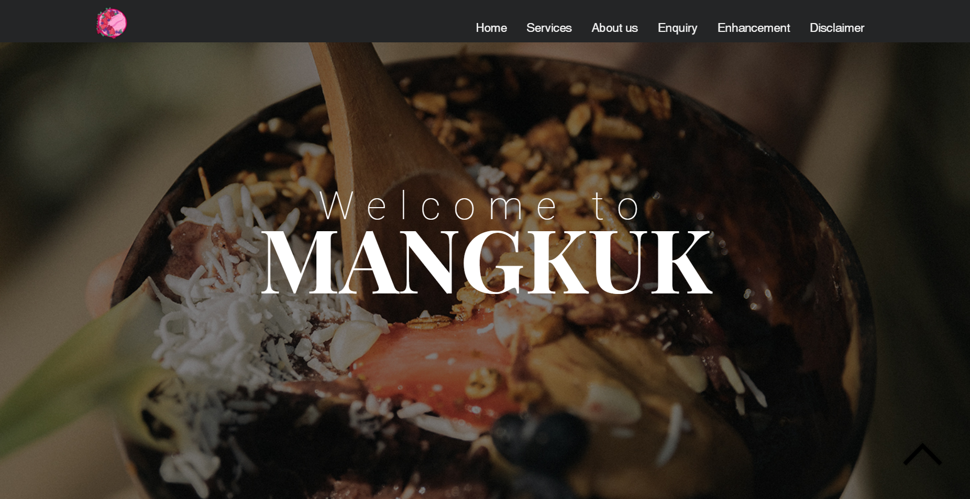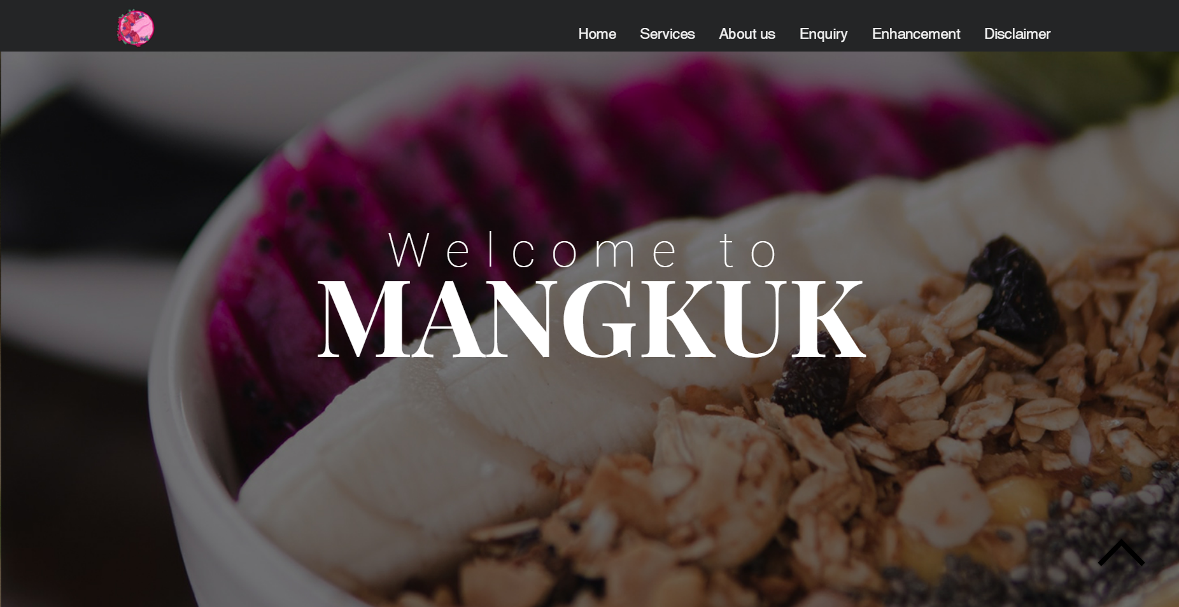

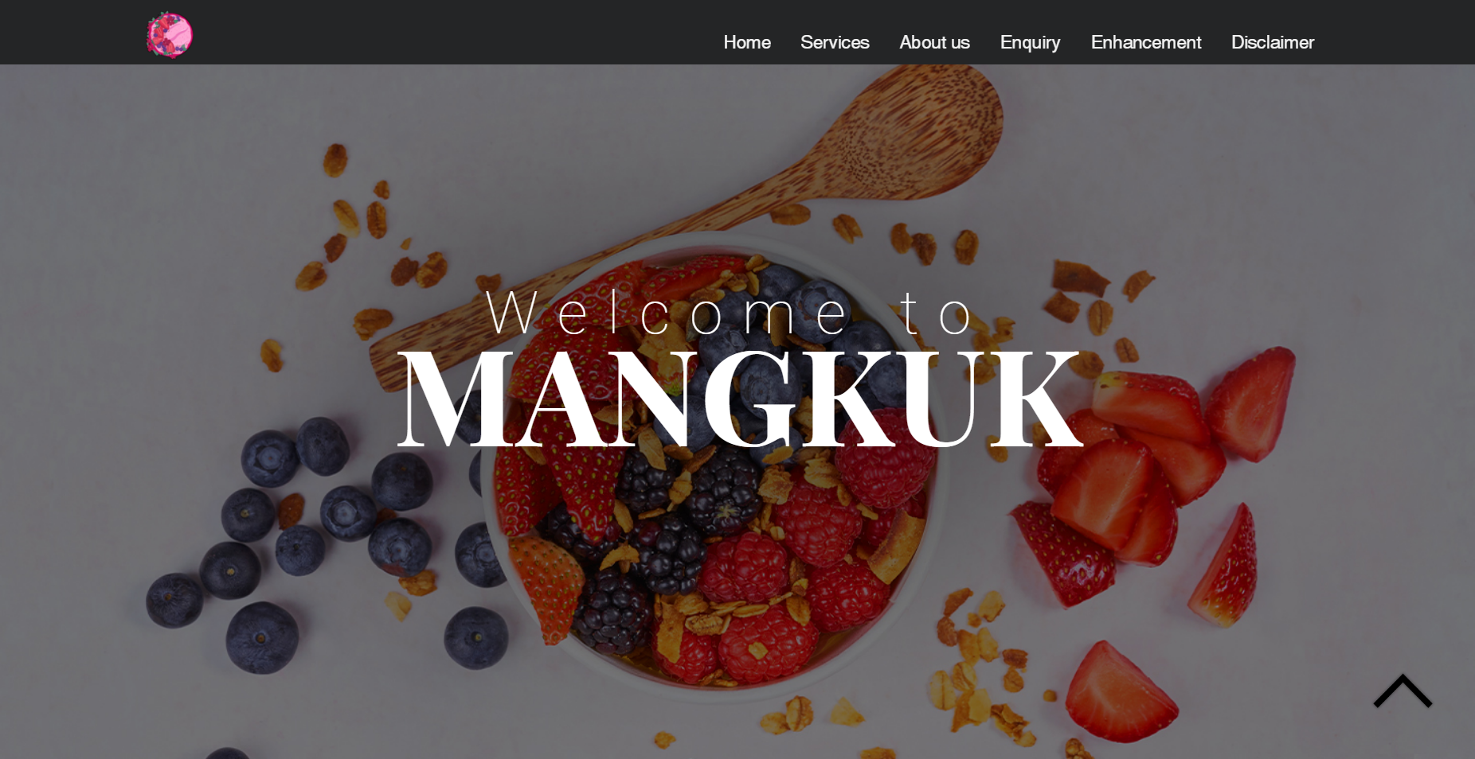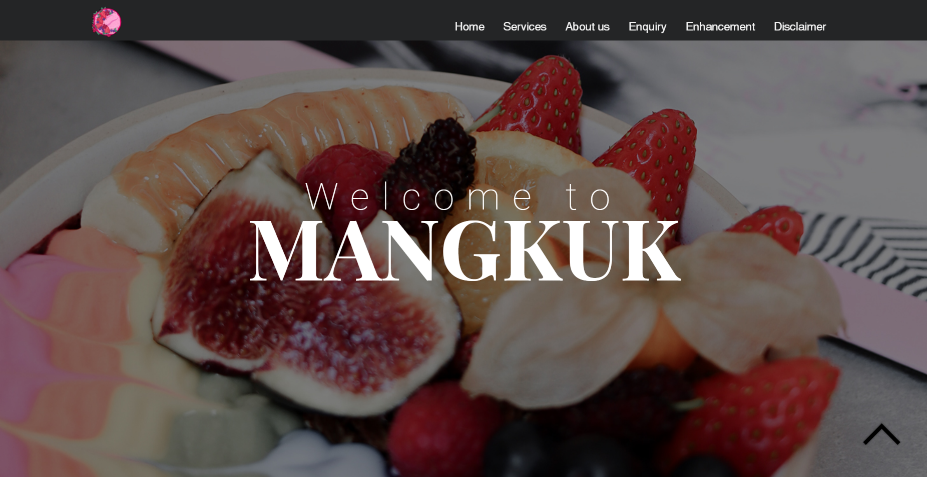

Slideshow can make the website to look more interactive. It allows users to have a preview of different type of the products in order to give them a roughly idea of the website. This can potentially extend users’ time spent on website as they can stay a bit longer to finish viewing all the images.

#### 2.2.1.2 Real-time clock

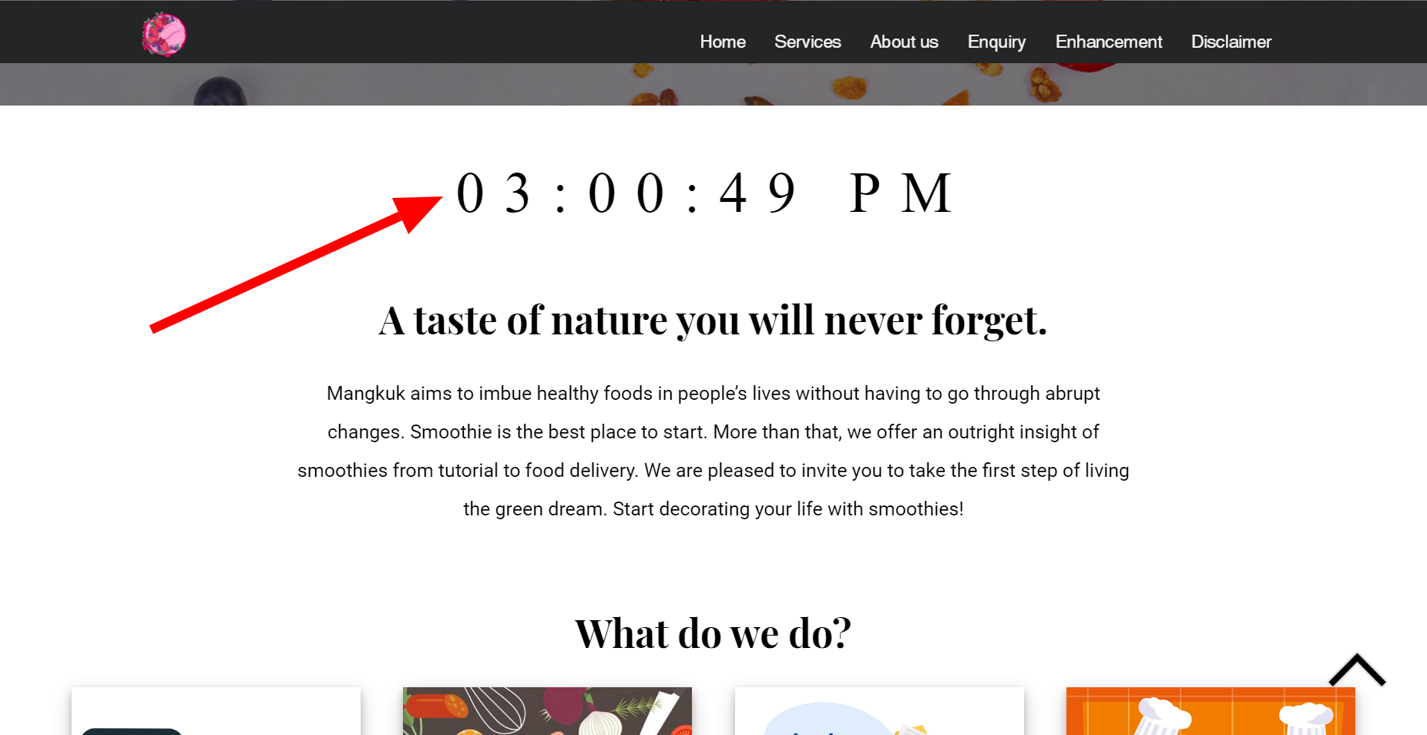

Real time clock helps users to check their time while still surfing on the website so that they do not have to minimise or close the browser to look at the time. This will help them to track their time for how long they have been on the website to avoid spending too much time on it.

#### 2.2.1.3 Scroll back to top button

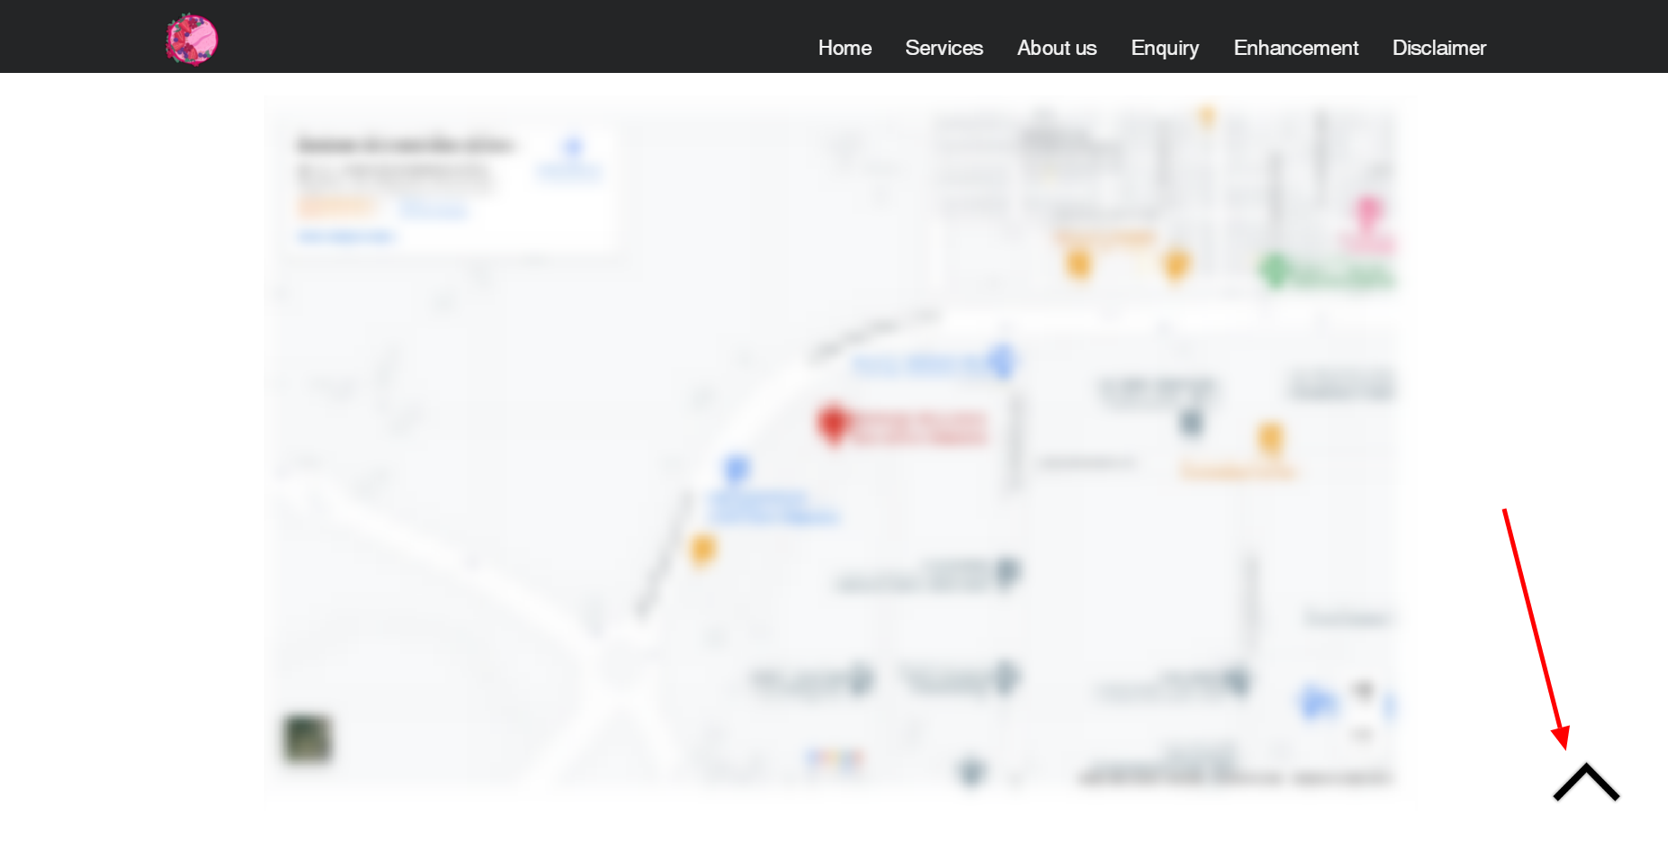

Despite having a constant navigation bar, users still can use the scroll back button to go up. This is mainly to let users view back the beginning of the page regardless from where they last stop. The button position will be fixed and follow the page from the top to bottom. The users can just left click it to go up.

# Assignment 3

## Description

### Basic requirements

* PHP is used to have individual header, footer and the commonly use design/ element which separate from PHP files. This will help to declutter the code in all files.

#### head.php

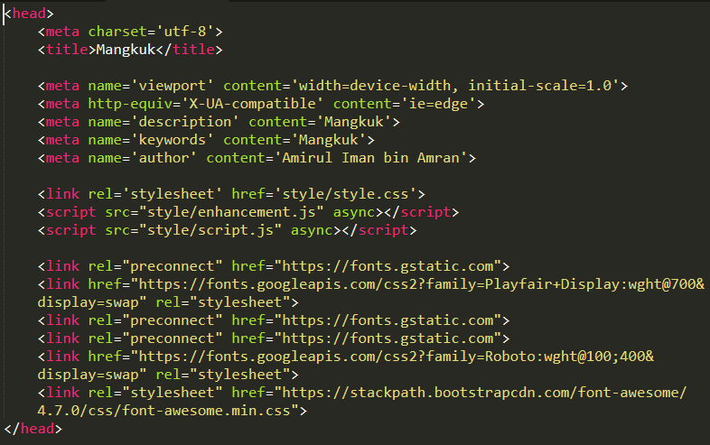

#### navigation.php

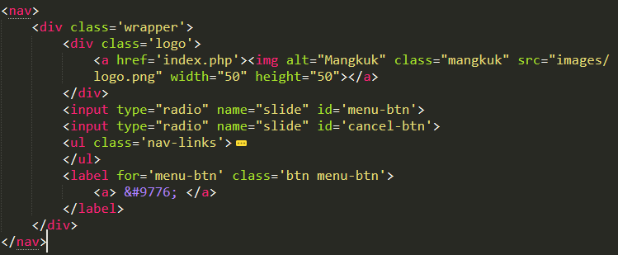

#### header.php

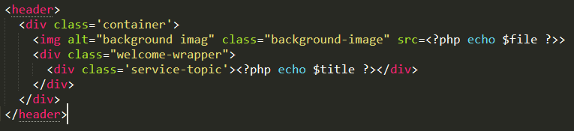

#### footer.php

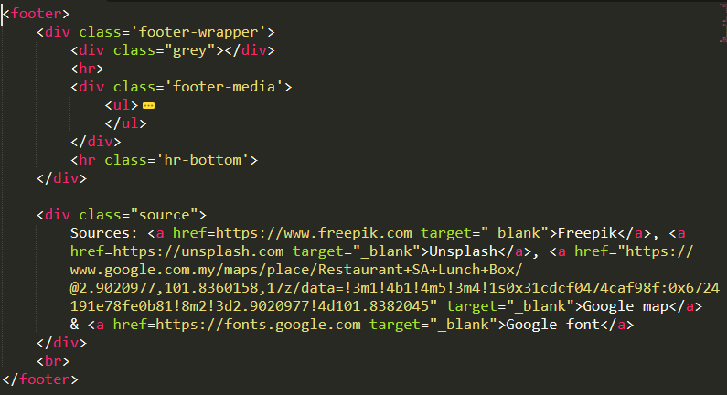

#### enquiry.php

It first try to connect with the database using *mysqli_connect()*. If it unable to connect, a text will appear to let the user know. In continuation, *Mangkuk* database and *enquiry* table are created.

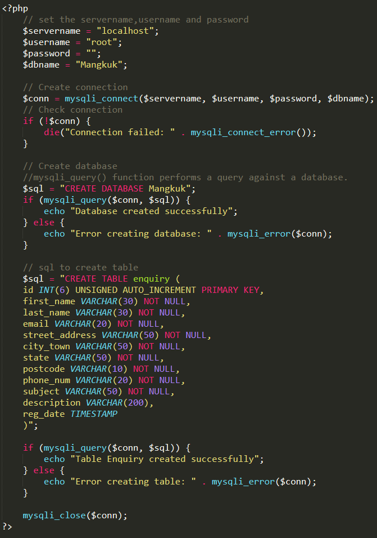

#### enquiry_process.php

It gets the data from the PHP using *$_POST* with variables assigned to each data. Originally, the data is from confirm.php which is for confirmation. From there, *INSERT INTO* statements is used in enquiry_process.php to transfer the data to the database according to its own table.

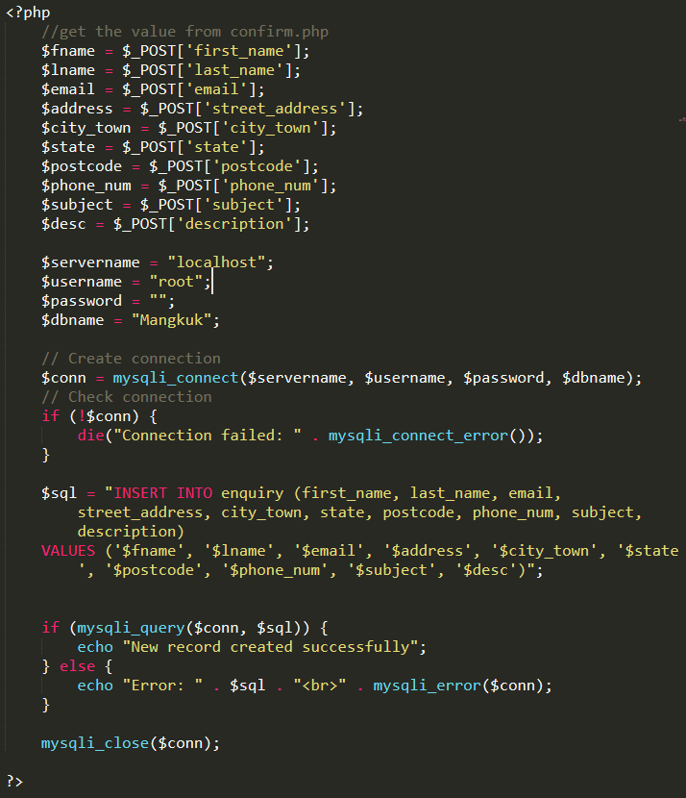

#### view_enquiries.php

It retrieves the data from the *enquiry* table under *Mangkuk* database using *SELECT* and *FROM* statements. Later on, it prints all the data using *echo*,masked by table elements. The data is mentioned through $row[]. For instance, $row[“first_name”] is to get the user’s first name.

Note: view_enquiries.php can only view the data without any alteration. To do so, management.php is responsible to edit & delete, it can be find on the navigation bar, by clicking *Admin*.

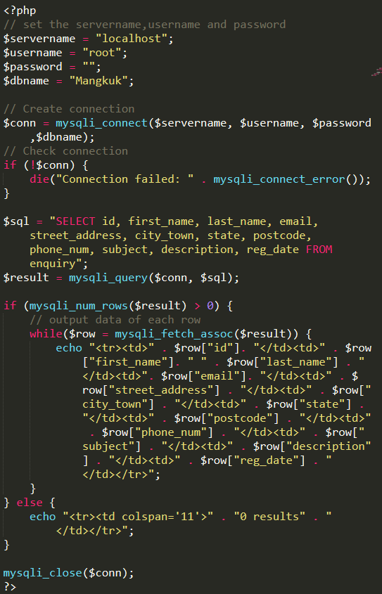

*[Provide brief description on how PHP is applied to the website]*

## MySQL database structure/schema

Database: Mangkuk

|  |  |
| --- | --- |
| *id* | *INT(6) UNSIGNED AUTO_INCREMENT PRIMARY KEY* |
| *first_name* | *VARCHAR(30) NOT NULL* |
| *last_name* | *VARCHAR(30) NOT NULL* |
| *email* | *VARCHAR(20) NOT NULL* |
| *street_address* | *VARCHAR(50) NOT NULL* |
| *city_town* | *VARCHAR(50) NOT NULL* |
| *state* | *VARCHAR(50) NOT NULL* |
| *postcode* | *VARCHAR(10) NOT NULL* |
| *phone_num* | *VARCHAR(20) NOT NULL* |
| *subject* | *VARCHAR(50) NOT NULL* |
| *description* | *VARCHAR(200) NOT NULL* |
| *reg_date* | *TIMESTAMP* |

*Table 1: Enquiry*

|  |  |
| --- | --- |
| *username* | *VARCHAR(30) NOT NULL* |
| *password* | *VARCHAR(30) NOT NULL* |

*Table 2: Admin*

*[Prepare a table to show MySQL database used in the website]*

## End Product

### User Management Module

This enchancement focuses on altering the data which are login, edit & delete options that available for the admin to use. Unlike the basic specified requirements, it only focuses on retrieving and displaying the data from the database. Further understanding of PHP-MySQL is required to execute this module properly. To do so, a programmer needs adequate knowledge of PHP and MySQL to make the alteration of the data. PHP is used to interact with MySQL.

Username: admin

Password: admin

Login page

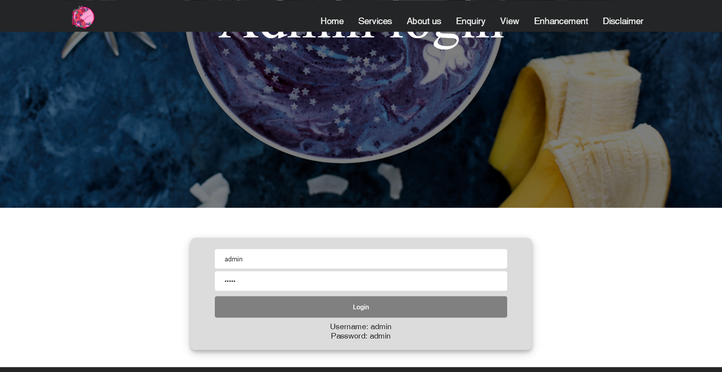

This is to ensure that only the owner can access to make changes to the data.

Management page

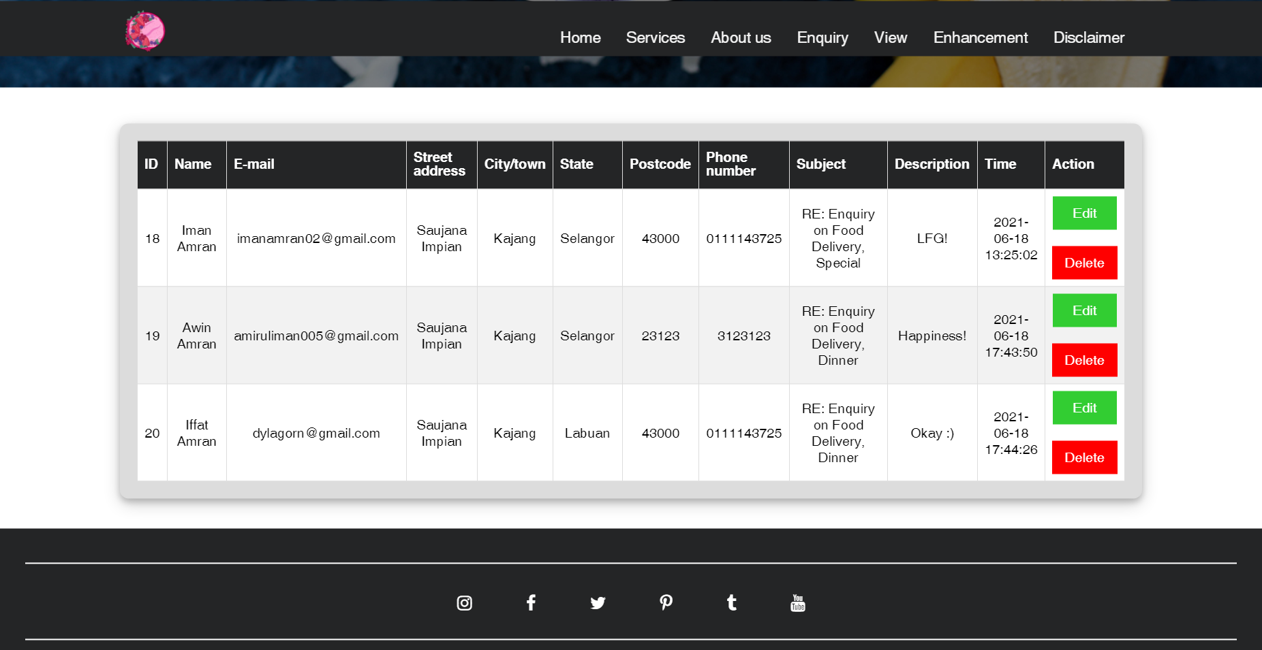

This page main function is to let owner view all the data that is available. In addtion, there are options that can be choosed, edit and delete. This adds more features for the owner to do with data.

Edit page

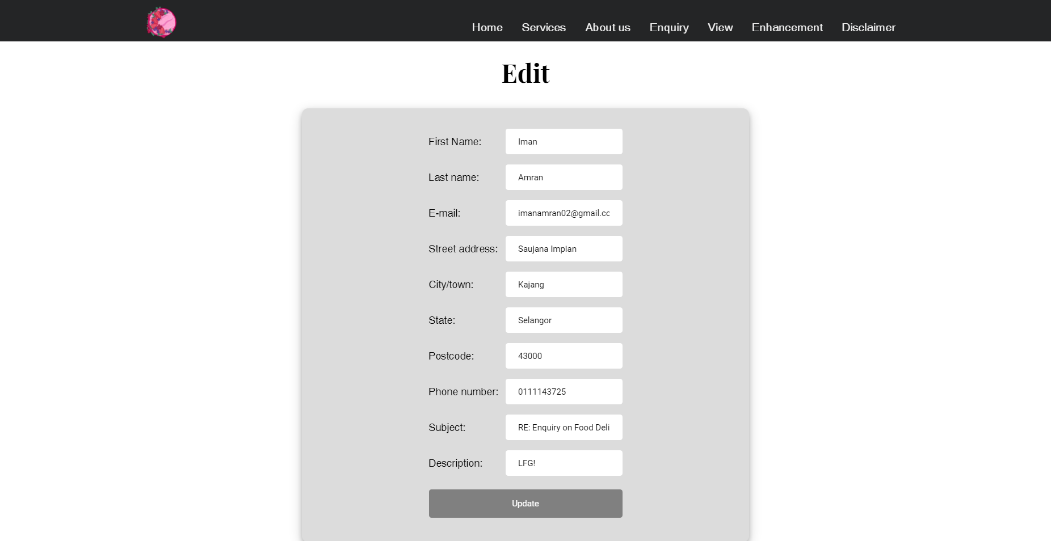

On this page, owner can alter the data based on the selected user.

Delete

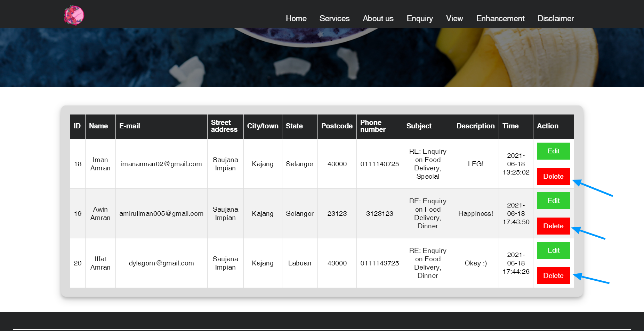

To delete, click the red button and it will delete the selected row on database.

### Confirmation

This is confirm.php that transfer data from enquiry.php to enquiry_process.php. $_POST statement is used to retrieve the data to display and assign them to new variables that will be sent to enquiry_process.php.

*[Describe the enhancements if any]*